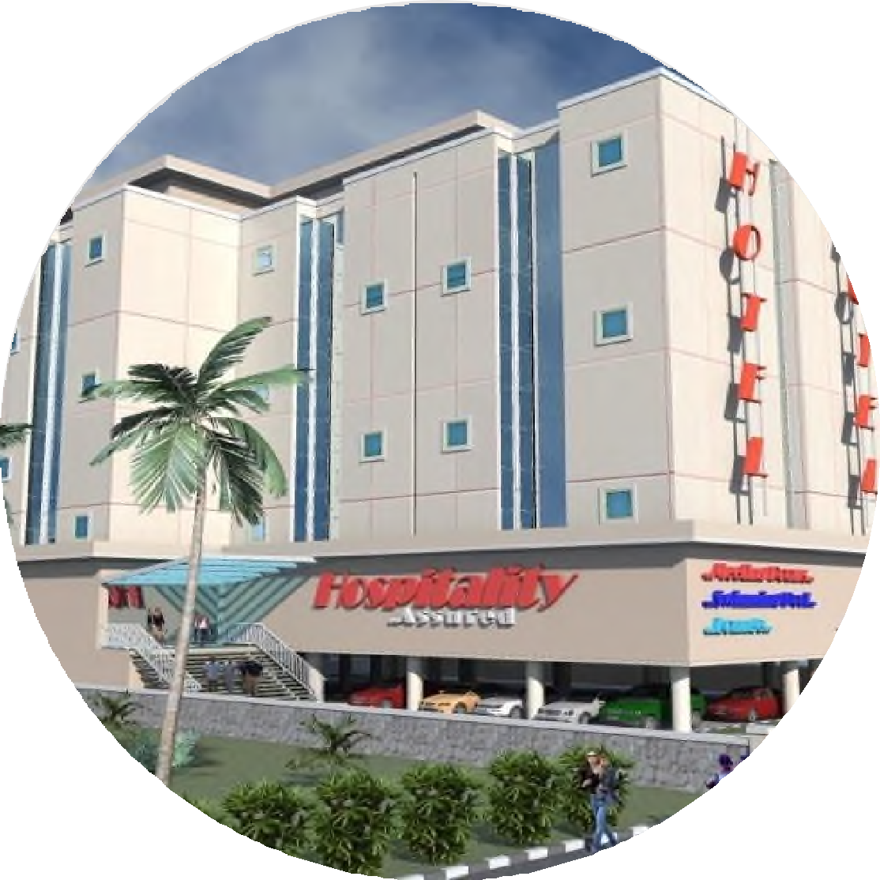

# THE BUILDS LINKS LIMITED

CIVIL ENGINEERING CONTRACTORS

## CONTENT

**About Us**

3

**Our Reach Our Services Our Clients**

6

5

9

10

**Our Team**

**Project Gallery**

2

## ABOUT US



**THE BUILDS LINKS LTD. TBL** is a civil

Engineering Construction firm Incorporated in Nigeria In 2001 with RC NO:418309

**OUR EXPERIENCE**

Our experience is in road and building construction and their associated structural, mechanical, electrical, cooling systems, in all sectors including Oil and Gas.

**OUR FOCUS**

is to provide proactive response to customers building needs through our hands-on approach coupled with our

3

experience and highly exposed professionals.

**ABOUT US CONT’D**

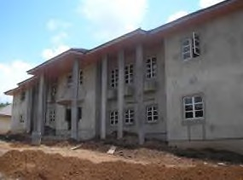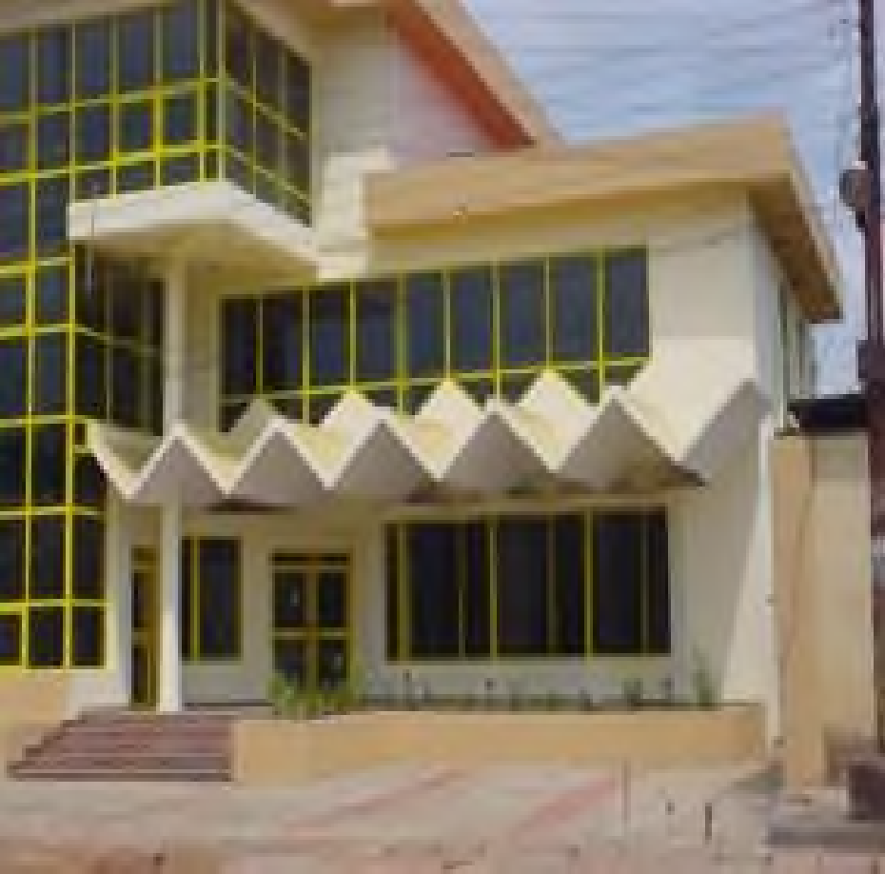

**VISION**

*Our vision is to add great value to the environment as intended by God at creation.*

**MISSION**

Our mission is to give our clients maximum satisfaction by the delivery of high quality jobs within the stipulated time frame at the best possible cost

4

# OUR REACH

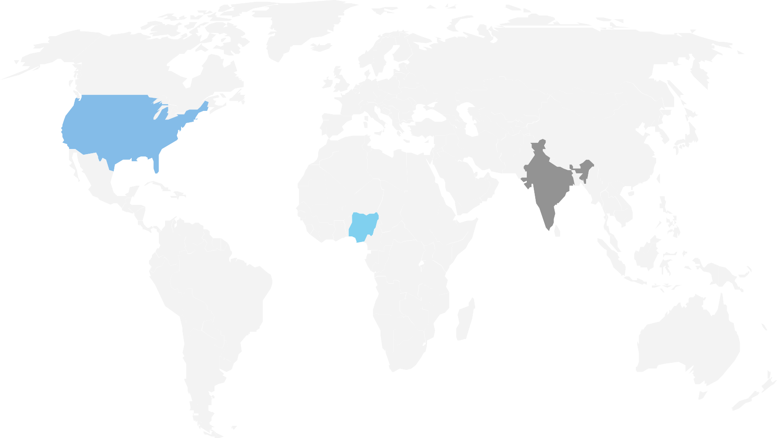

### Lagos, Nigeria

*6B FAFOWORA CLOSE MAGODO GRA PHASE II*

*+23480 3342 0498*

### Rivers, Nigeria

*11 OHAETO STREET, D – LINE PORT HARCOURT,*

*+23480 3704 2304*

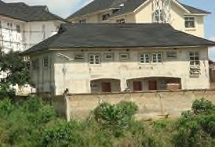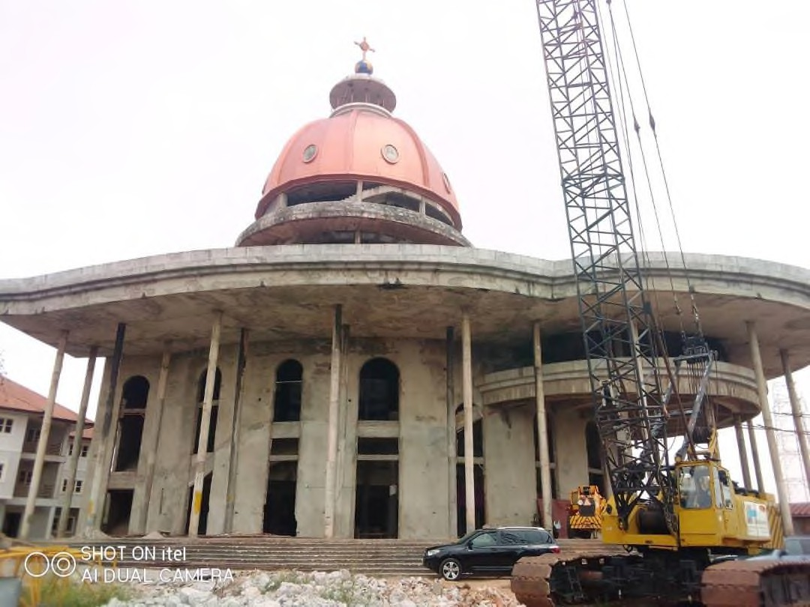

6

## OUR SERVICES



**CONSTRUCTION OF SINGLE AND MULTI- STOREY RESIDENTIAL COMMERCIAL AND INDUSTRIAL BUILDINGS.**

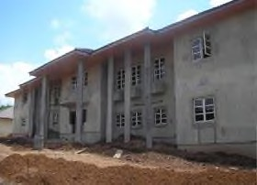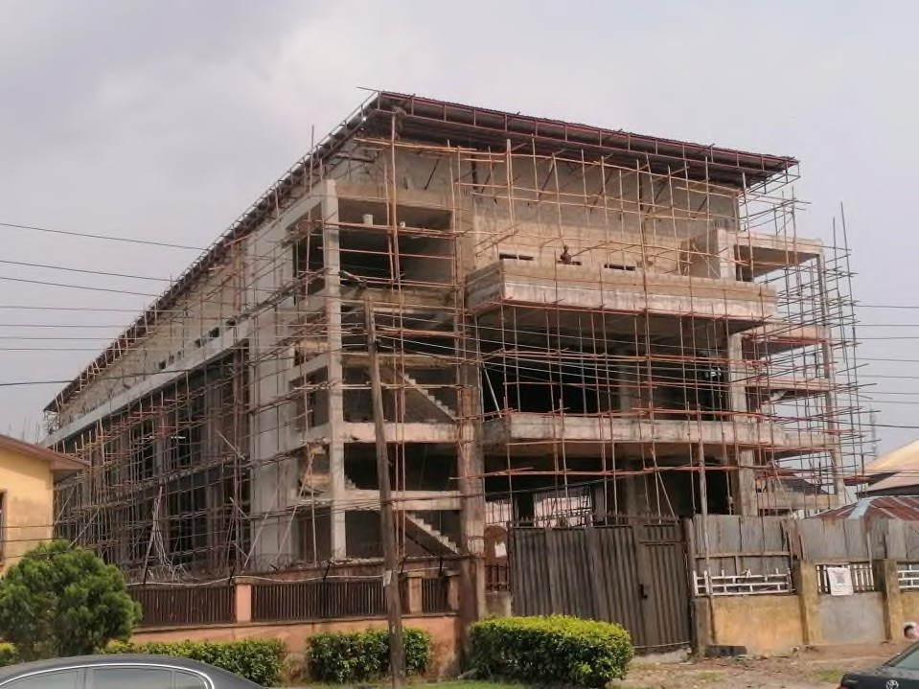

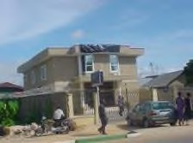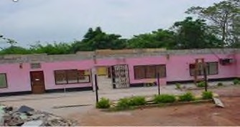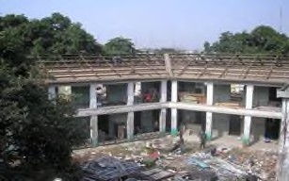

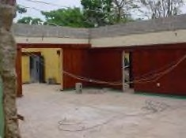

7



**RENOVATION WORKS OF ALL FORMS.**

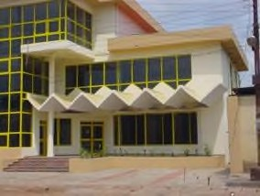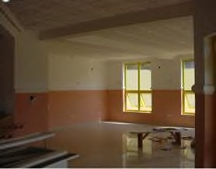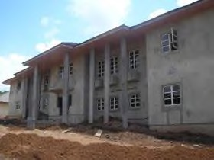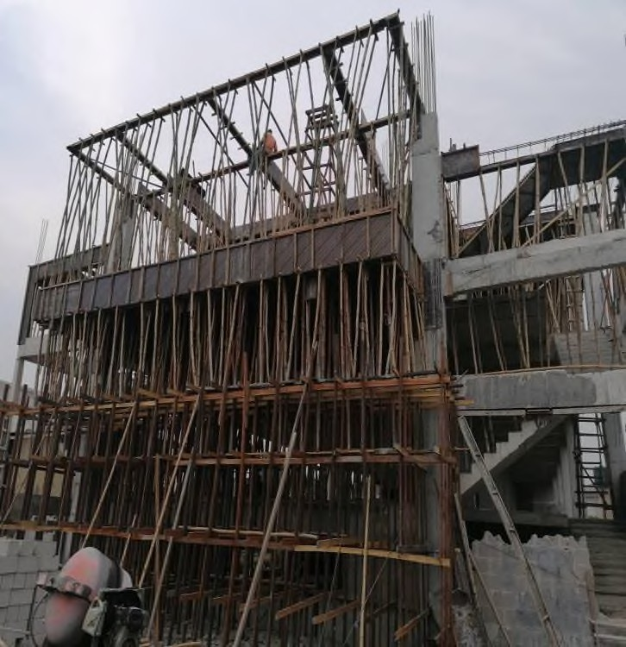



**MAINTENANCE OF RESIDENTIAL, INDUSTRIAL, COMMERCIAL BUILDINGS AND ESTATES.**

8

|  |  |  |  |  |  |
| --- | --- | --- | --- | --- | --- |
| **OIL & GAS** | **FINANCIAL INSTITUTION / CHURCH / SCHOOL** | **GOVERNMENT** | **MANUFACTURING/GE**  **NERAL COMMERCE** | **AVIATION** | **INDIVIDUALS** |
| DRILL PET. LTD | GATEWAY BANK PLC | ABIA STATE GOVT | RANGE TECHNOLOGIES LTD | ARIK AIR NIGERIA. | MR. F. OGURU |
| SOFU ENERGY  RESOURCES. | LIVING FAITH  CHURCH | LAGOS STATE GOVT | HARSPORA NIGERIA  LTD |  | ALHAJI S. OJEBODE |
| EMRGING STAR RES. LTD | COVENANT UNIVERSITY | UNIVERSAL BASIC EDUCATION BOARD | OJEMAI FARMS LTD |  | OJE’S PALACE |
| SEPLAT PETROLEUM DEVELOPMENT COMPANY LTD | FAITH ACADEMY, OTA | AKWA IBOM STATE GOVERNMENT | HOBARK INTERNATIONAL LIMITED |  | CHIEF H. IHEBOM |
| MOBIL PRODUCING UNLIMITED | FAITH ACADEMY,  PORT HARCOURT | RIVERS STATE POST PRIMARY SCHOOL BOARD | ROCKSON ENG. CO LTD |  | BARRISTER I.A.  ADEDIPE |
| STERLING OIL EXPLORATION & PRODUCTION COMPANY |  | NIGER DELTA DEVELOPMENT COMMISSION | DATCO- RIVERS CASSAVA PROCESSING COMPANY LTD |  | CHIEF OPENA ANOBILI |
| FOUNDATION SYSTEM |  |  | DOME NIG. LTD |  | J.I.A |

9

|  |  |  |  |  |  |
| --- | --- | --- | --- | --- | --- |
| **OIL & GAS** | **FINANCIAL INSTITUTION / CHURCH / SCHOOL** | **GOVERNMENT** | **MANUFACTURING/GE**  **NERAL COMMERCE** | **AVIATION/**  **HOSPITALITY** | **INDIVIDUALS** |
| UNITERM NIG. LTD | CATHOLIC UNIVERSITY, ABUJA | EKITI STATE GOVT | BAMTURY VENTURES | VHELBHERG IMPERIAL HOTEL | MR. OSCAR IGBOKWE |
| CB GEOPHSICAL SOLUTION LTD |  | ONDO STATE GOVT | PALM & CRUDE LTD |  | MR IFEANYI OKPARA |
| LOBAYOR GLOBAL VENTURES |  |  |  |  | MR NJUARE  BISSONG |
| IMAR MULTI CONCEPT ENTERPRISES |  |  |  |  | MR DELE ADESINA |
| TECON OIL LTD |  |  |  |  |  |
|  |  |  |  |  |  |
|  |  |  |  |  |  |

9

## OUR TEAM

OLUROTIMI A. SOLARIN

(MNIA)

MANAGING DIRECTOR/CEO

Solarin has a B.Sc. and M.Sc. in Architecture with over 35 years professional experience in building construction

ALUKO SUNDAY G

DEPUTY MANAGING DIRECTOR

**HND, Accounting, MBA Finance**

ENGR. GREGORY A.

SENIOR PROJECT ENGINEER

**BSC, MSC Civil Engineering. COREN**

VICTOR NGAH

PROJECT ARCHITECT

**BSC Architecture**

11

BURAIMOH KOREDE

SURVEYOR

HND, Bsc Land Surveyor, SUCOR

ENGR. DIRISU IYAMAH

SITE MANAGER 1

HND Civil Engineering, COREN

ENGR. SAMSON ALIU

PROJECT ENGINEER

BSC Civil Engineering

ONYESORO OBINNA

ENGINEER 1

BSC, Civil Engineering

12

OHIKHUEMEN KEHINDE

JOHN

MECHANICAL/ELECTRICAL

ENGINEER

HND, Electrical & Electronic Engineering

ENGR. BLESSING AZUBUIKE

QA QC ENINEER

BSC, Civil Engineering. COREN

AFURUOBI HEAVEN’S

ARCHITECT 1

BSC. Architecture

KINAKAH JOHN

ARCHITECT 2

BSC. Architecture

13

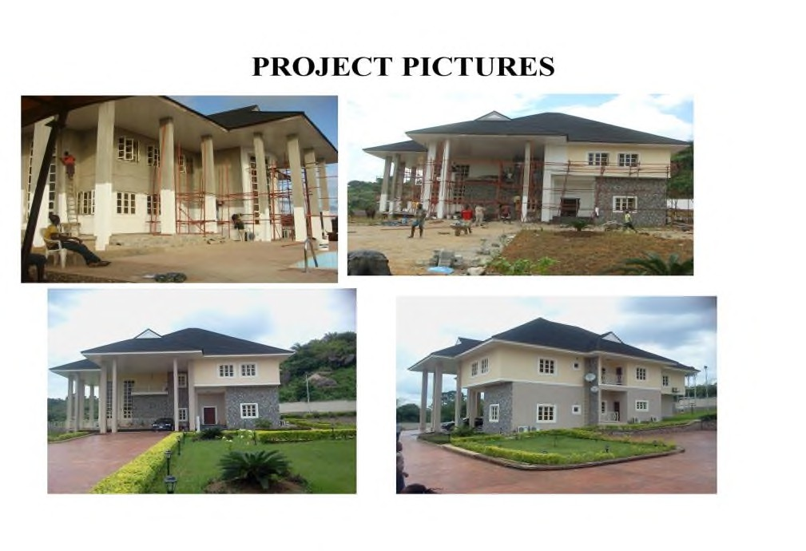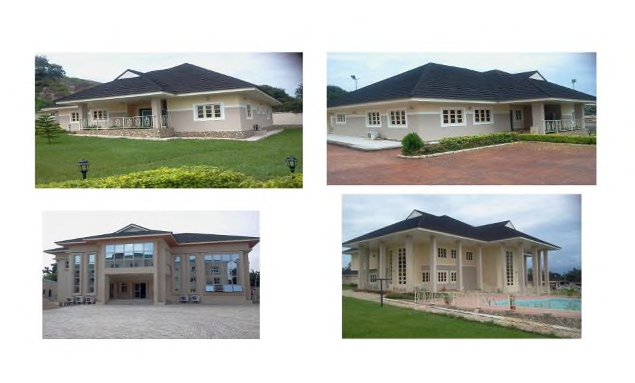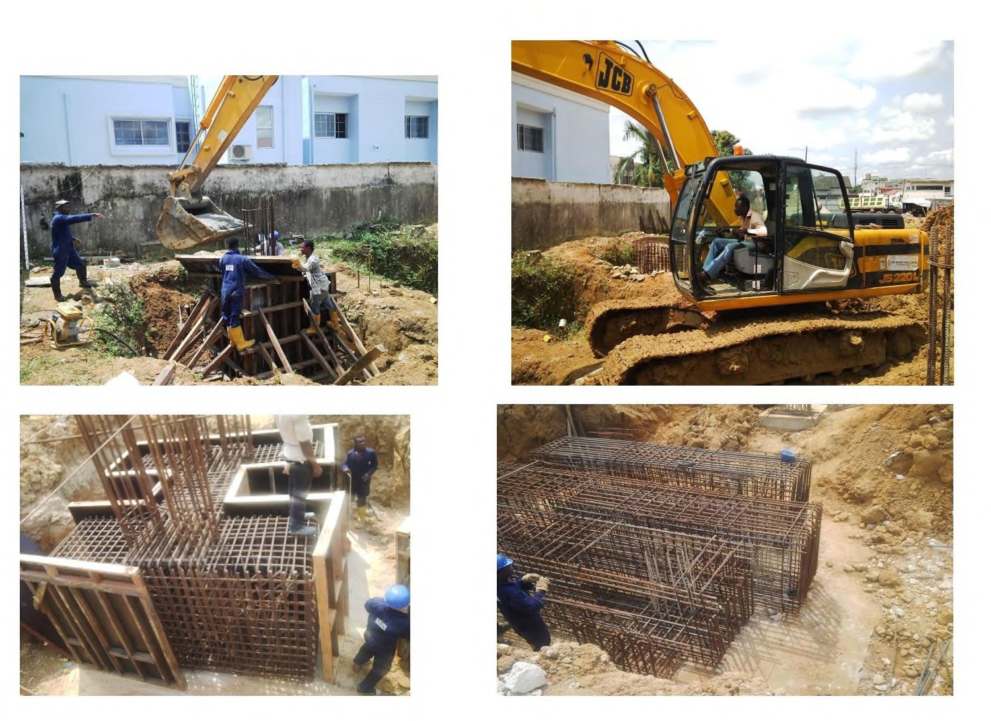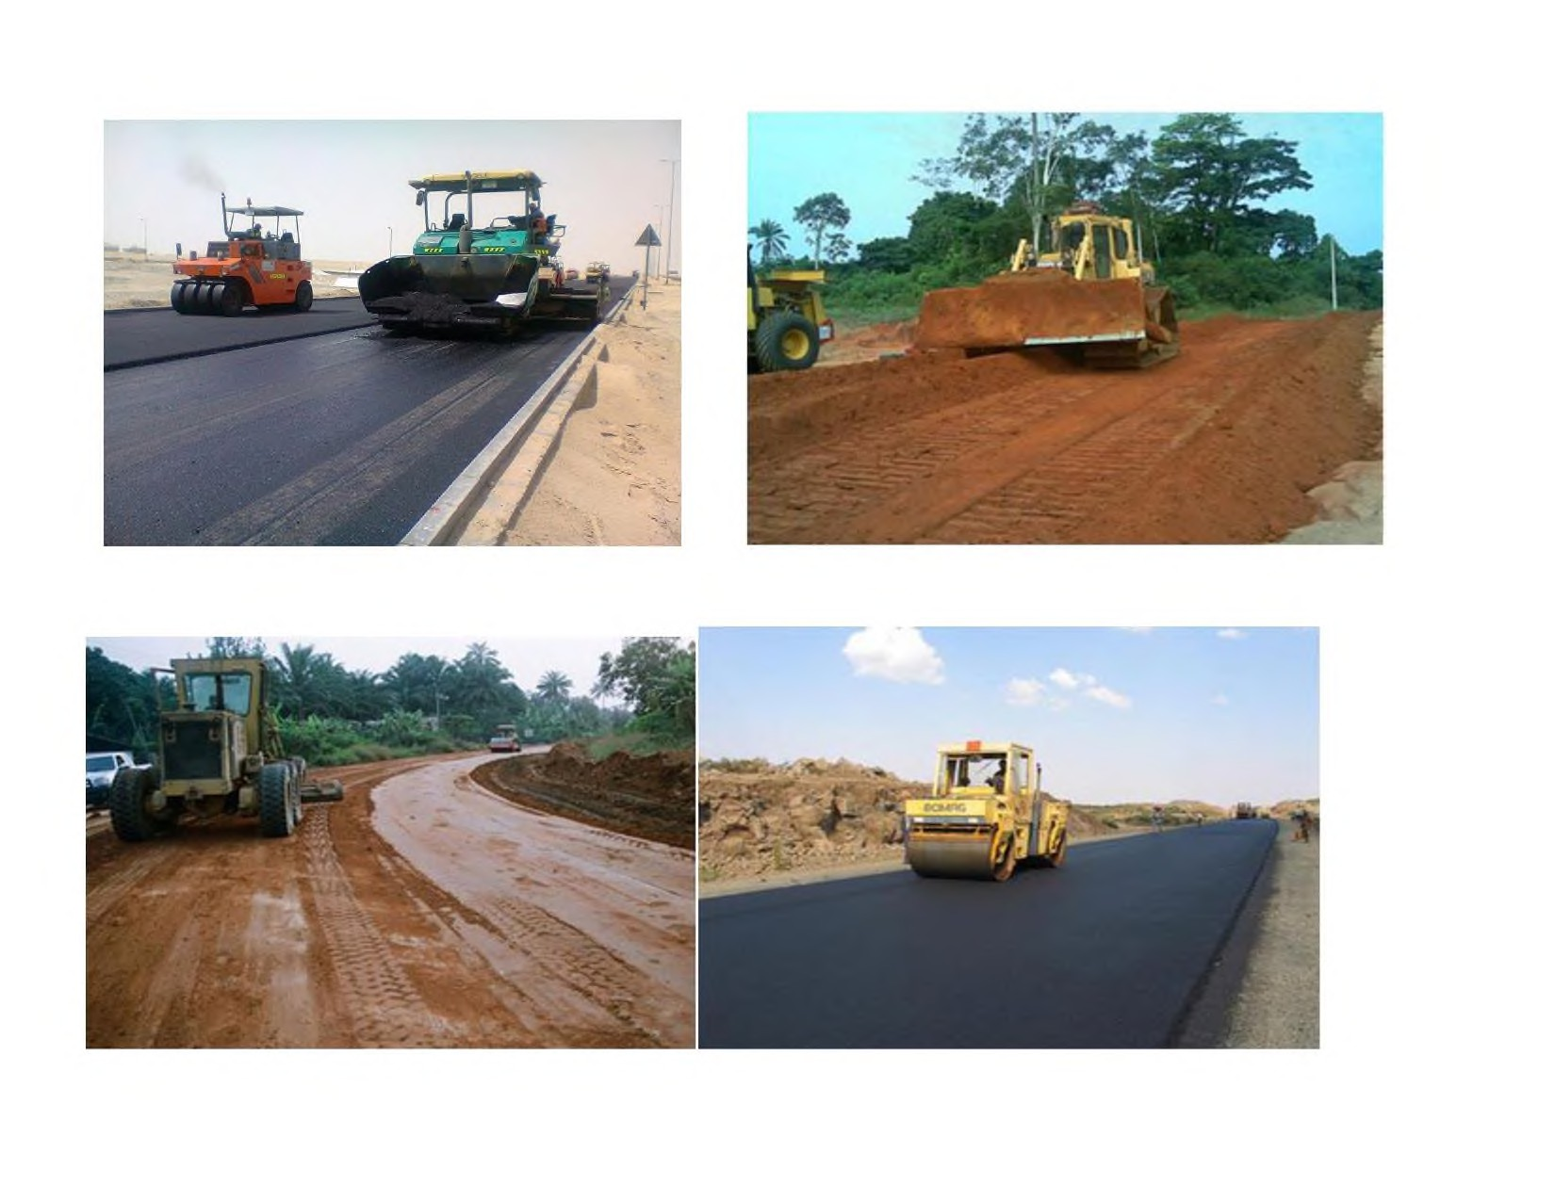

RESIDENTIAL BUILDING AT OBA-ILE AKURE REBISI HOTEL AT GRA PORT HACOURT & ROAD WORK AT BENIN

14



REBISI HOTEL AT GRA PORT HACOURT & ROAD WORK AT BENIN

15

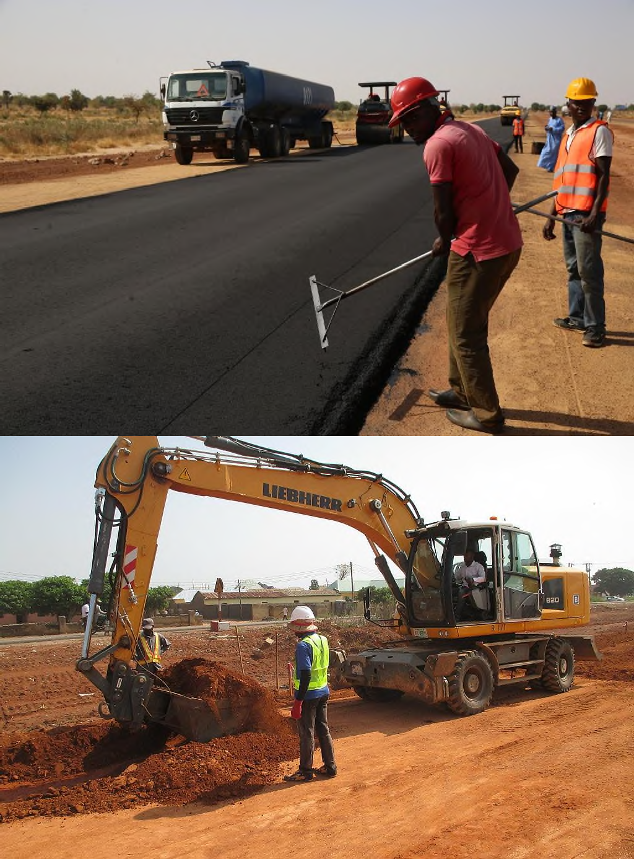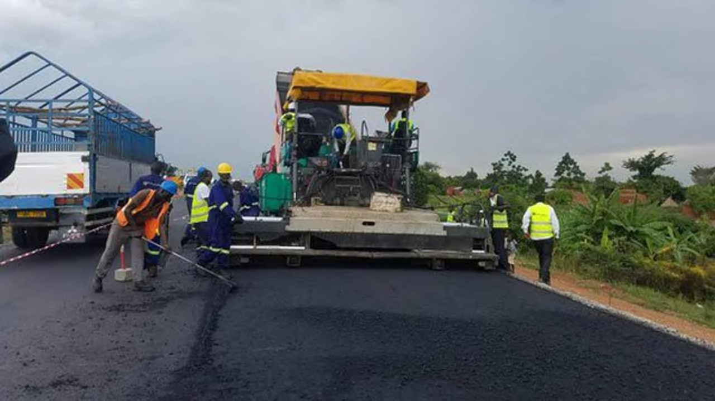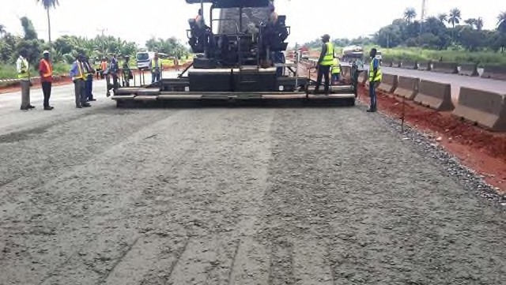**ROAD WORK PICTURE**

16

REBISI HOTEL AT GRA PORT HACOURT



17

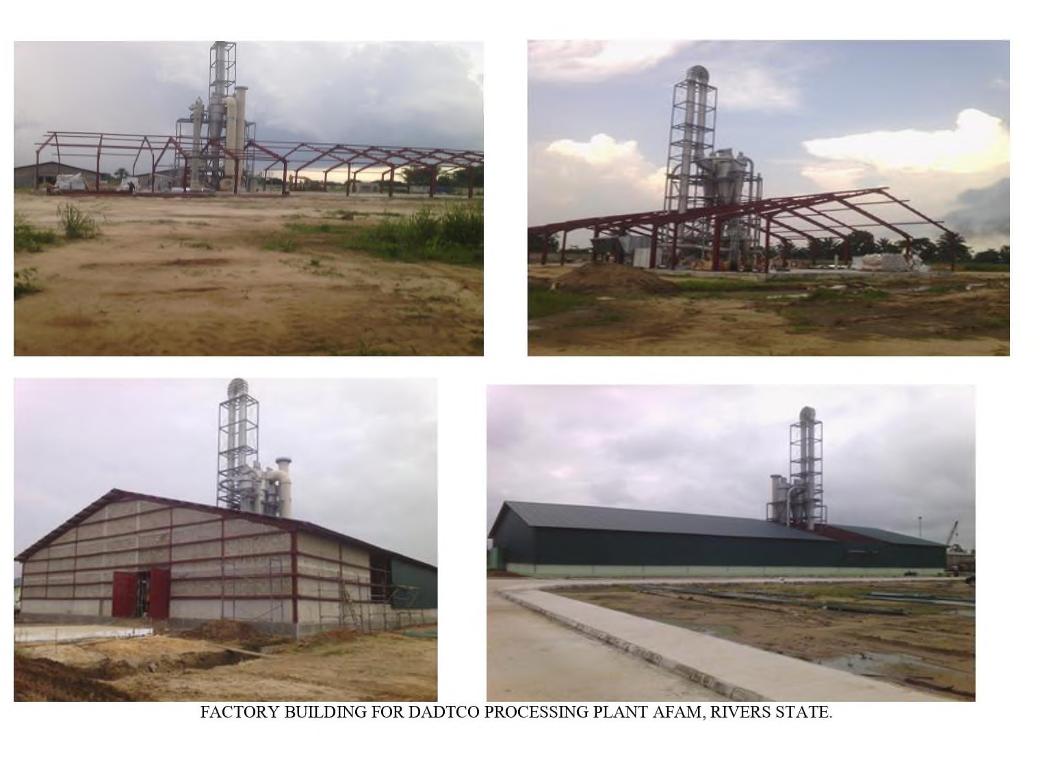

18

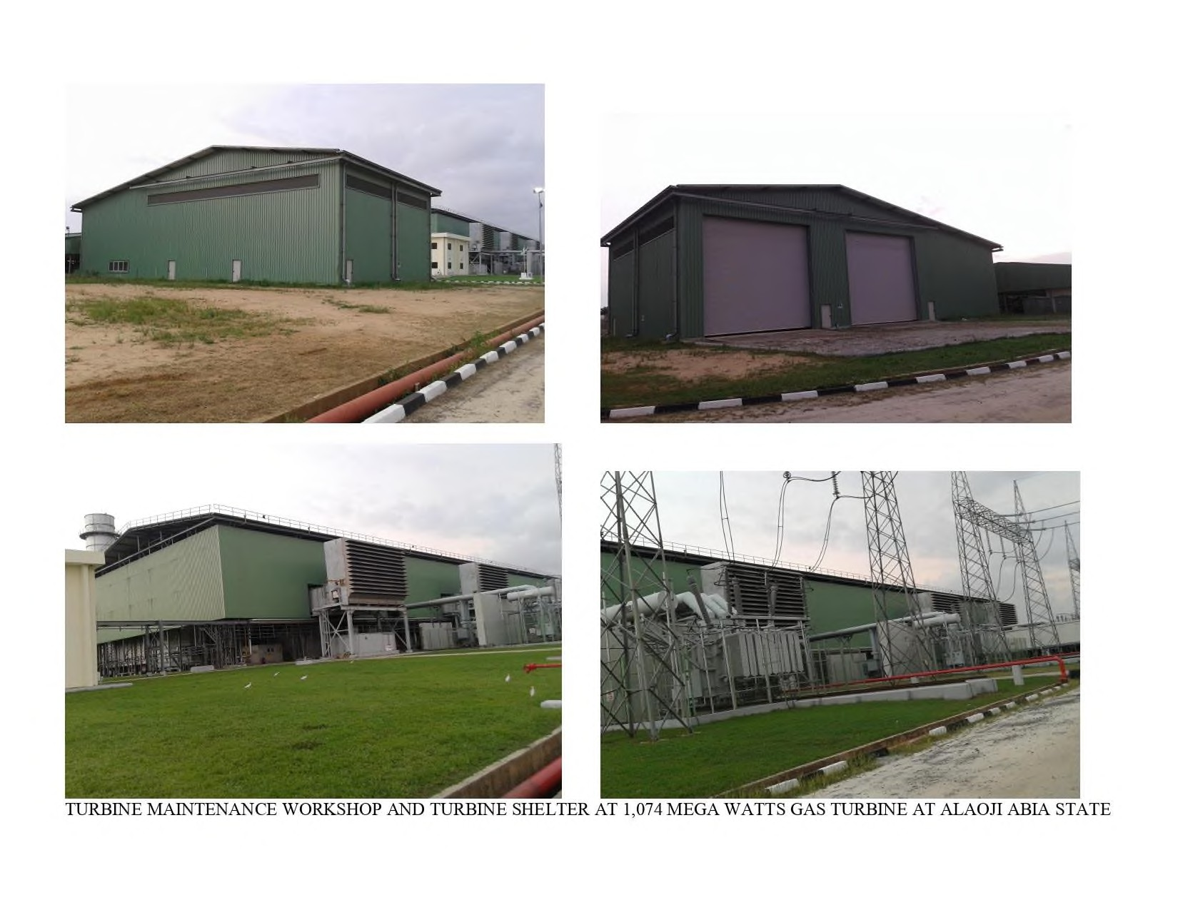

19

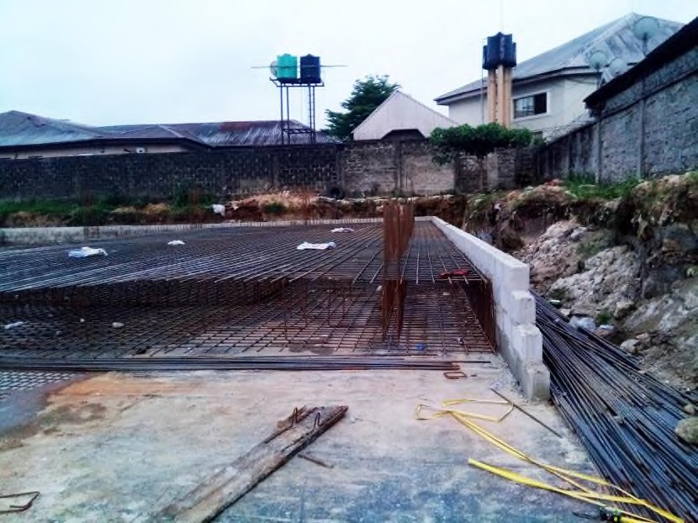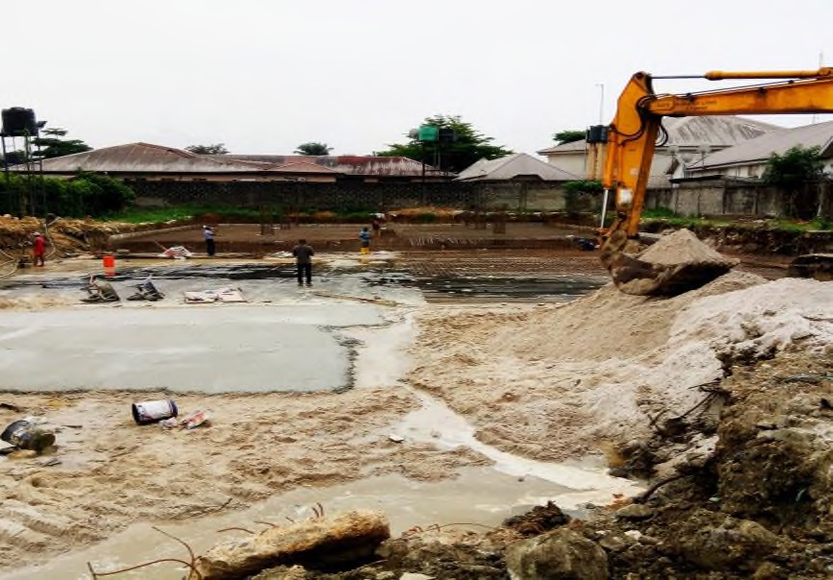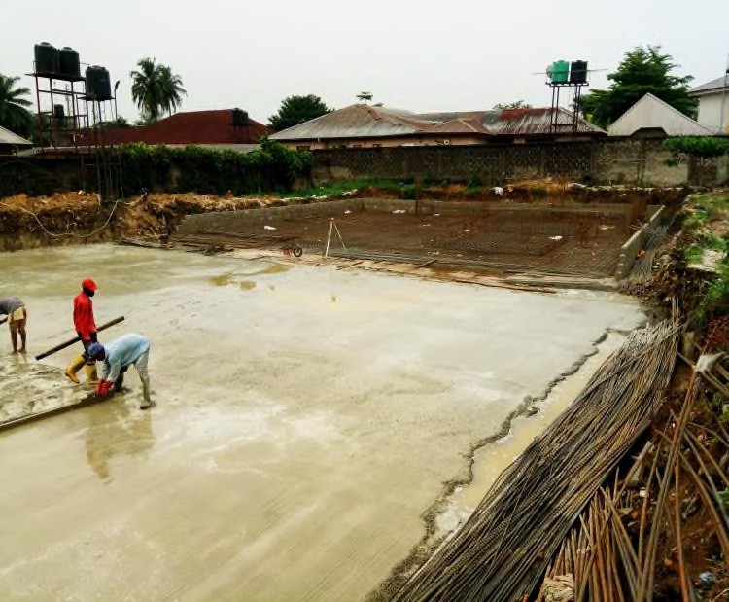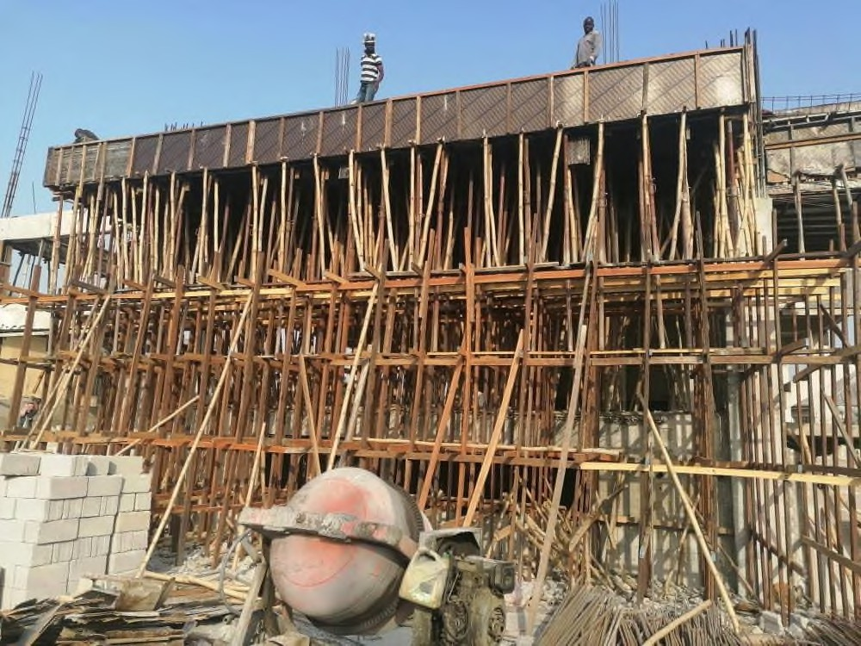**MULTI-LEVEL EVENT CENTER AT WOJI ROAD GRA PORT HARCOURT**

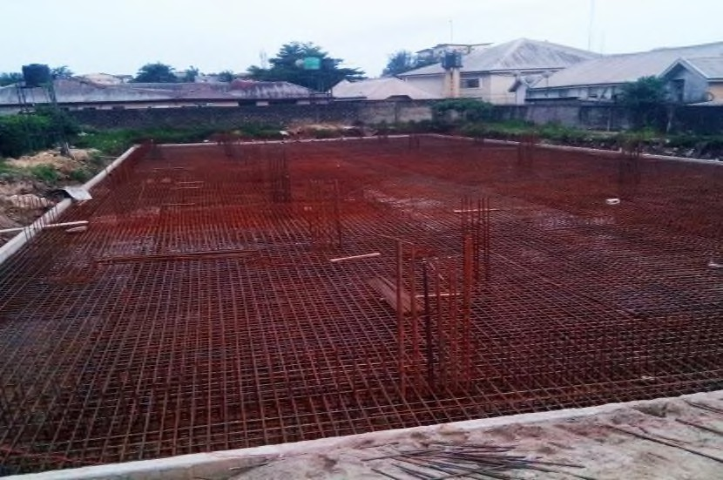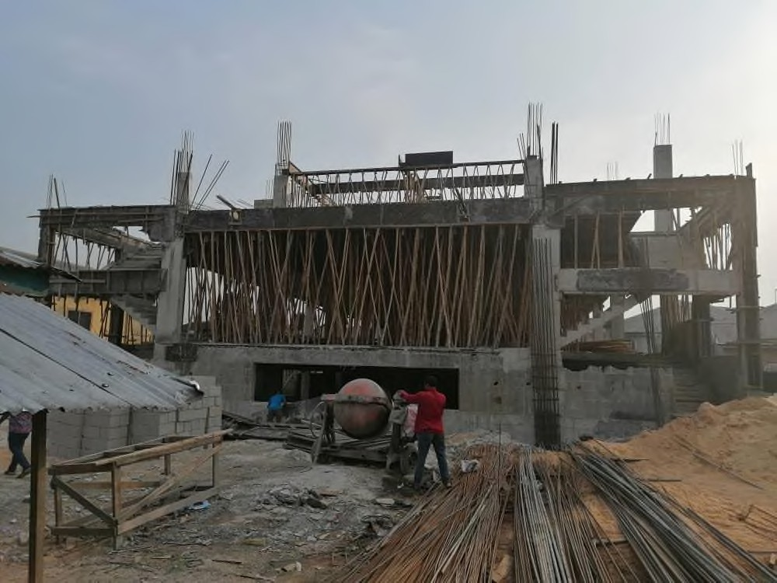

20

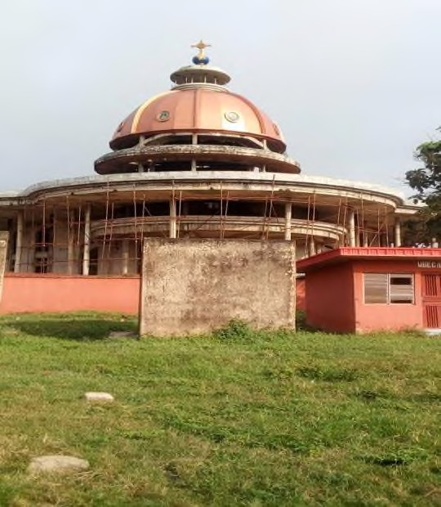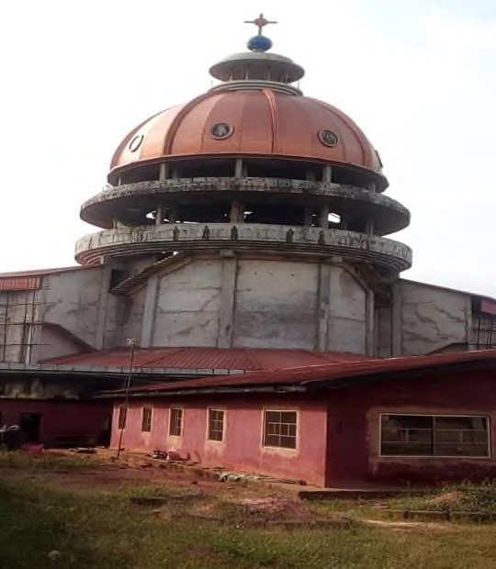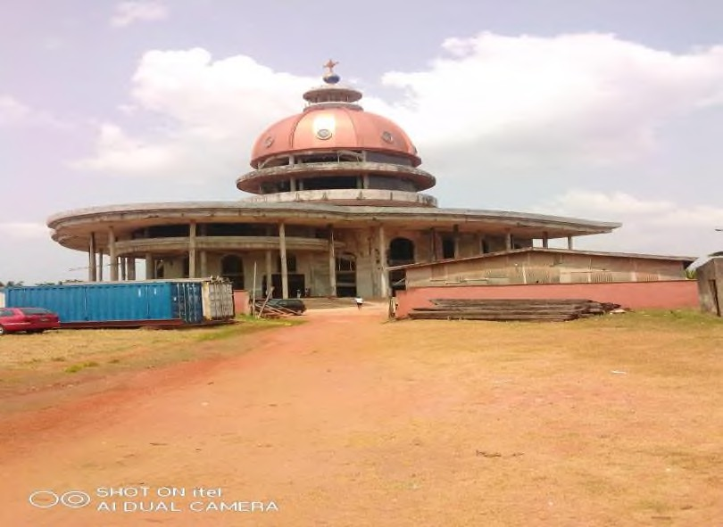**EVENT CENTER AT WOJI ROAD GRA PORT HARCOURT AND DOME CONSTRUCTION FOR CATHOLIC CHURCH SABONGIDA ORA, EDO STATE**

21

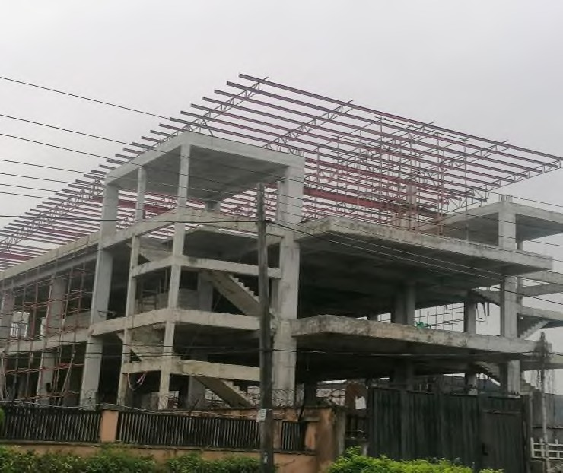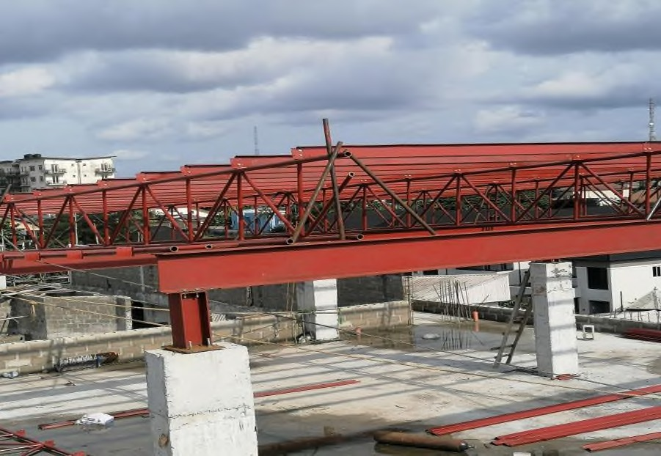

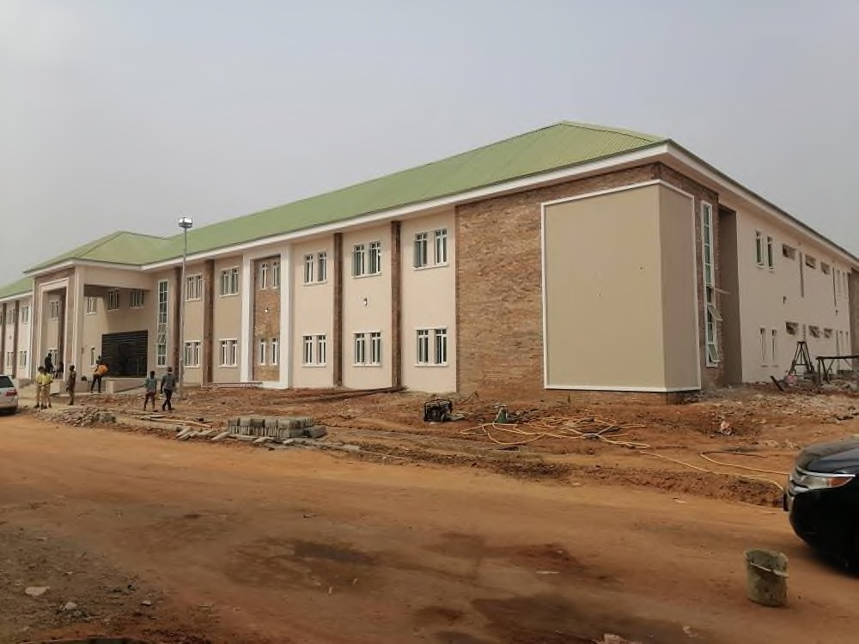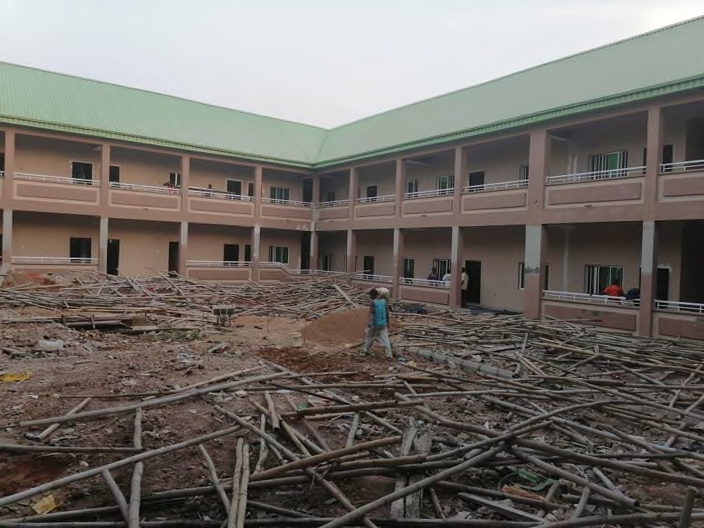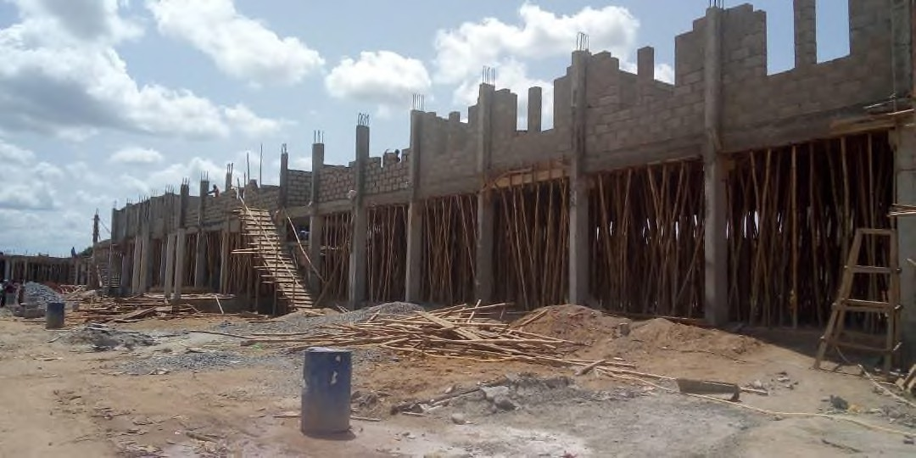**HOSTEL BUILDING FOR FAITH ACADEMY, CANANNLAND OTA**

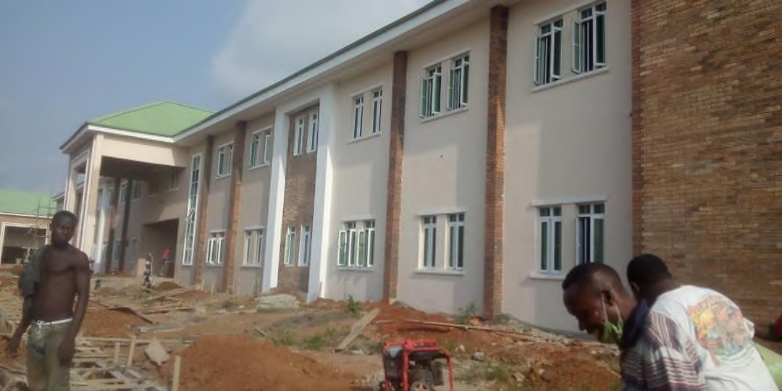 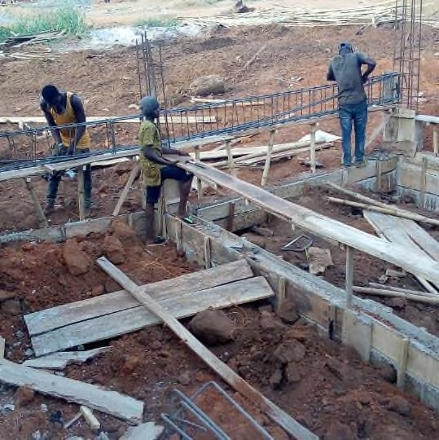

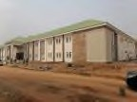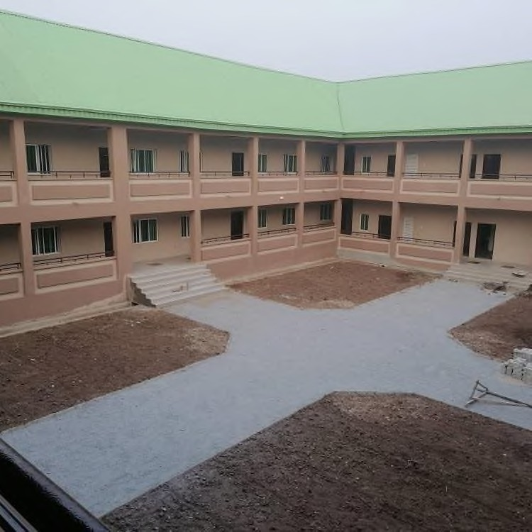

22

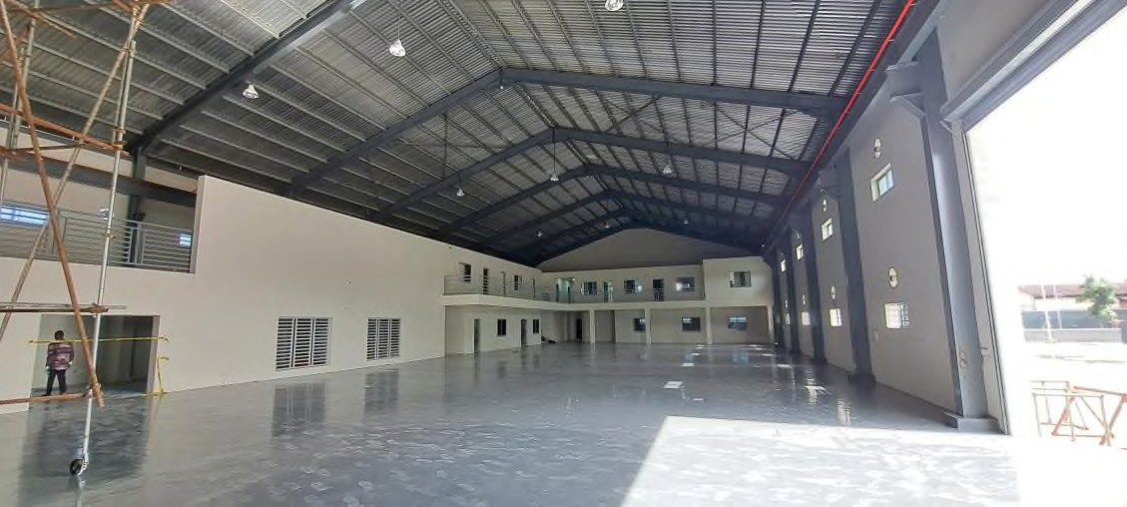 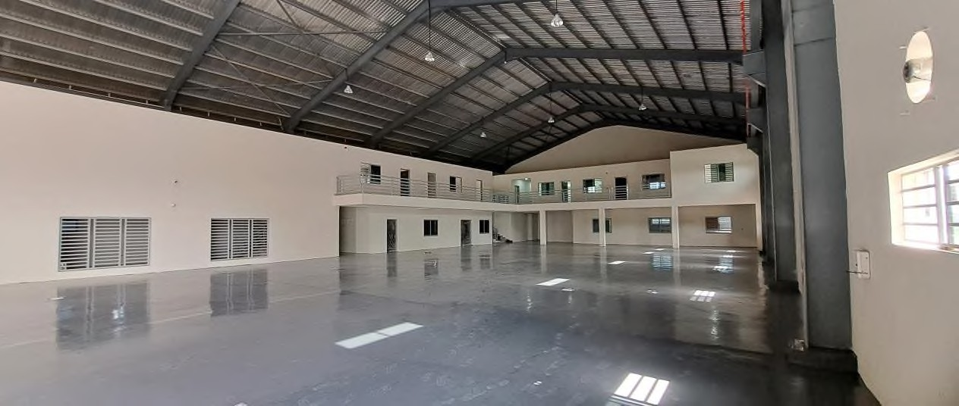

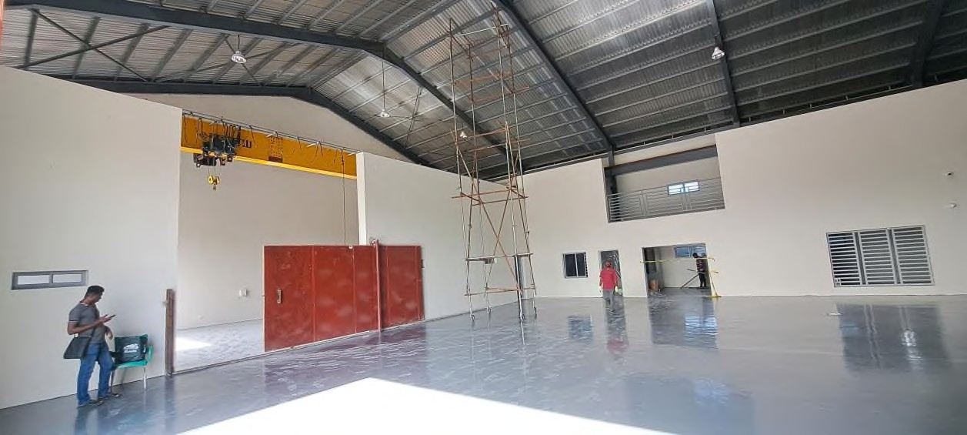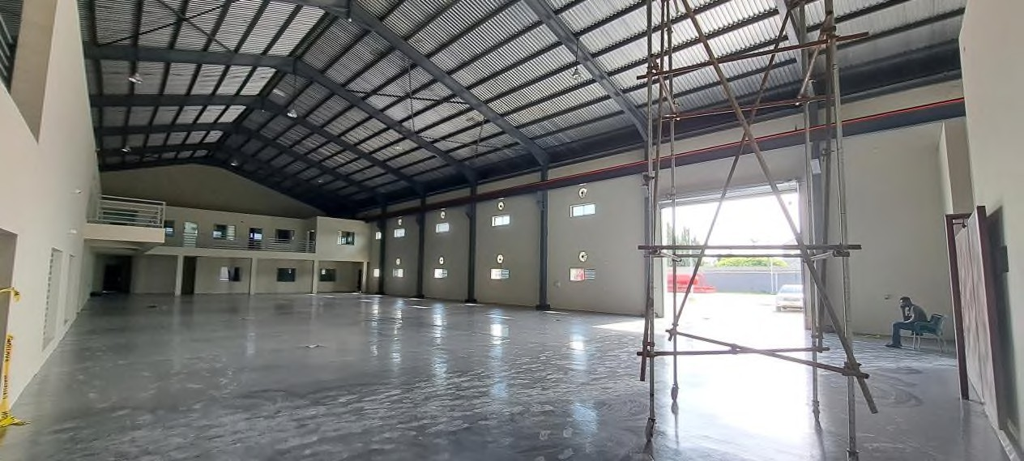

23

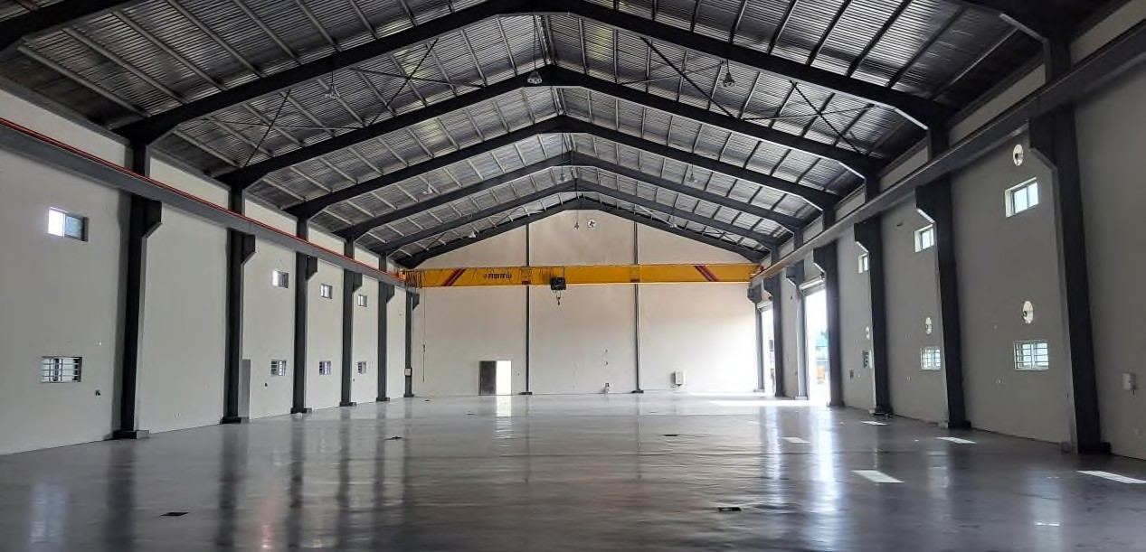 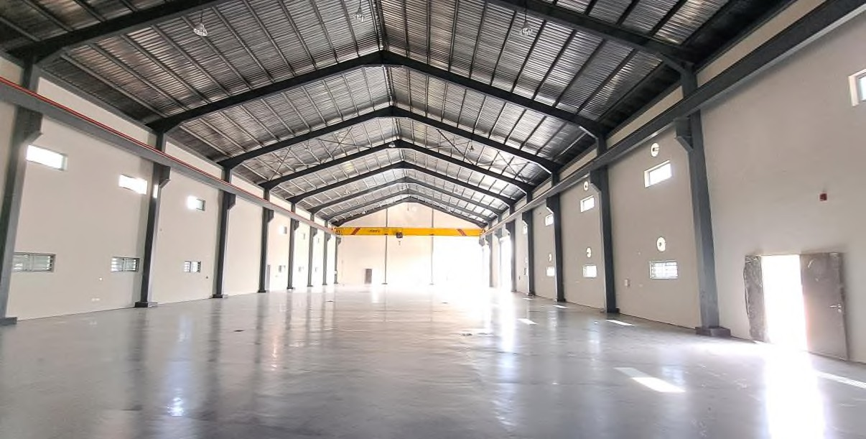

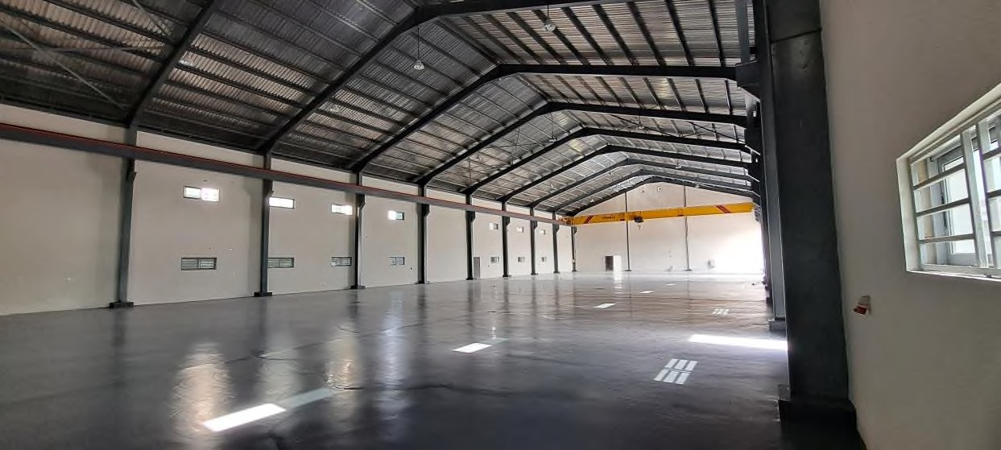

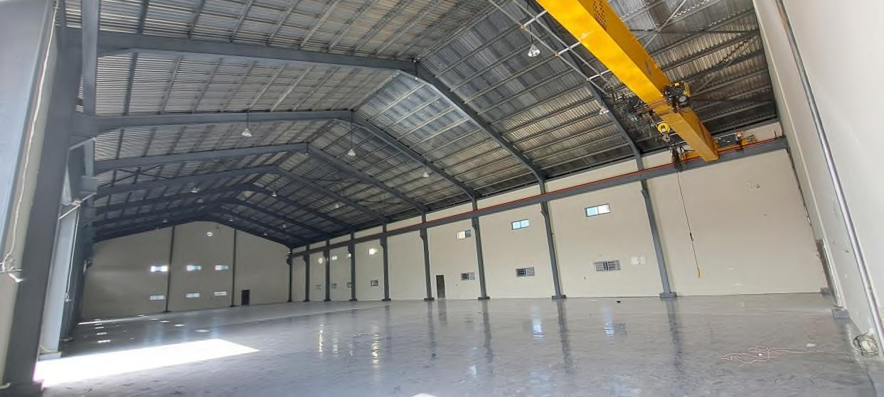

24

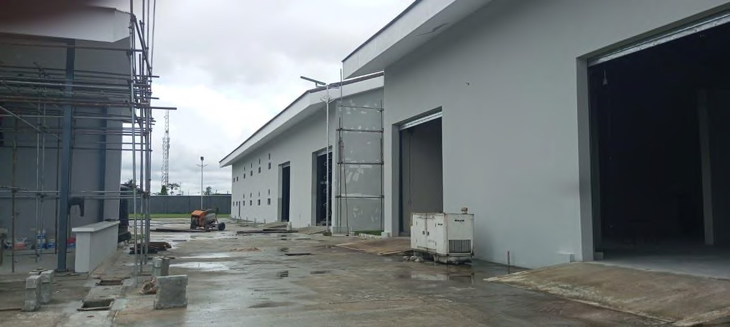

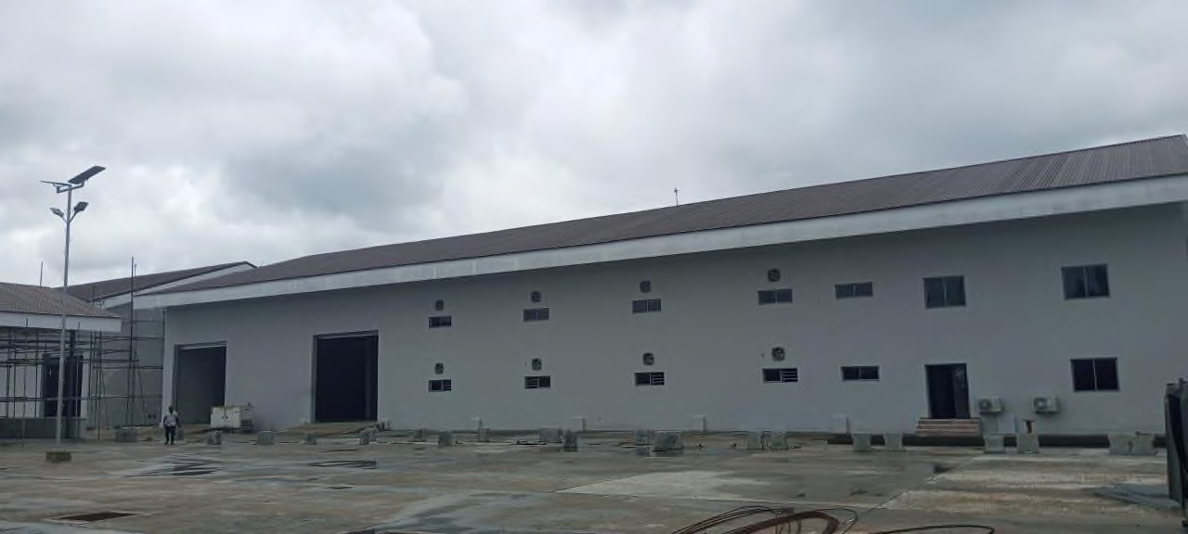 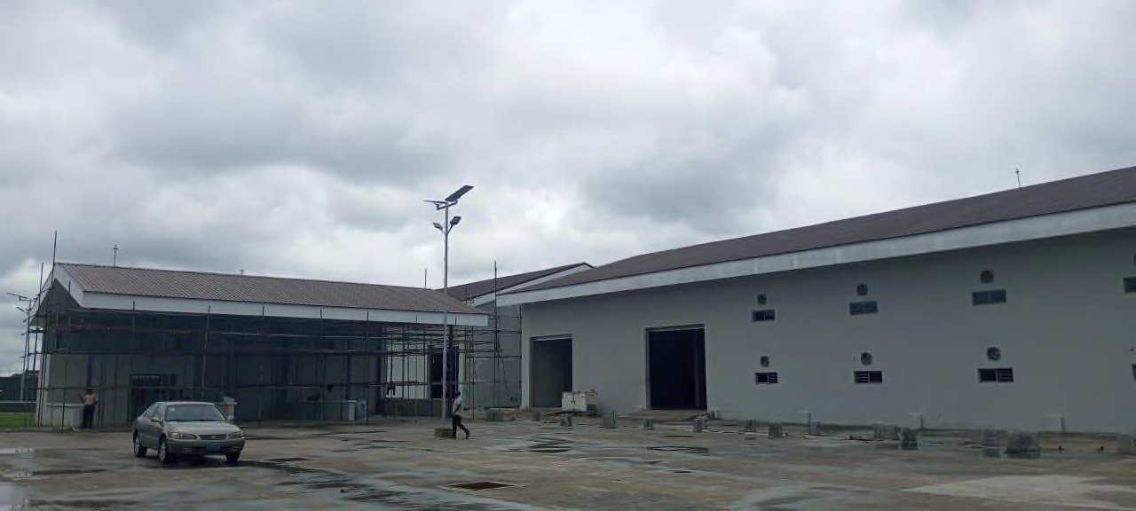

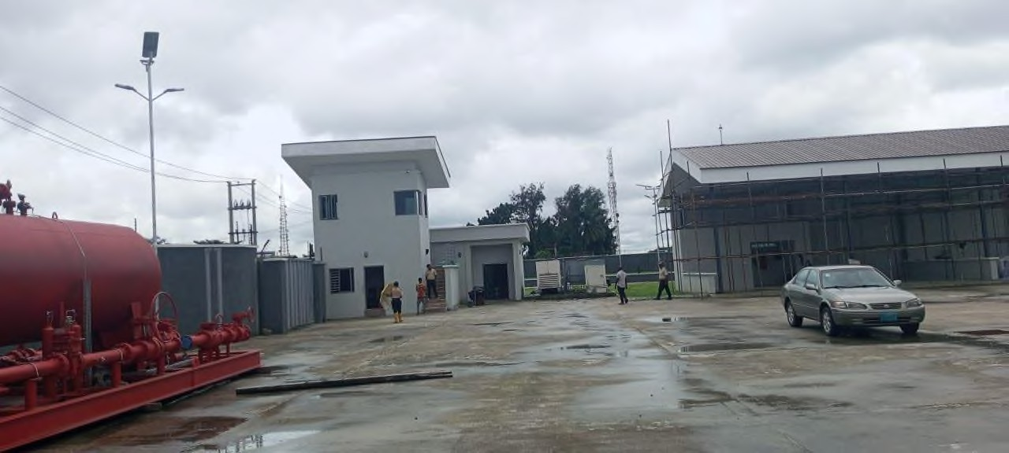

25

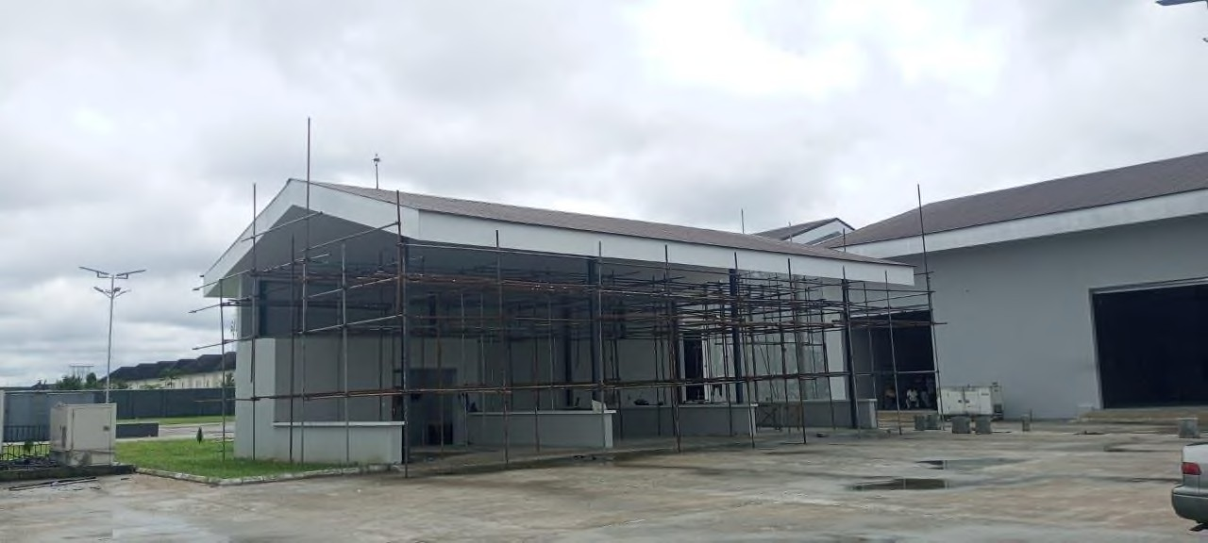

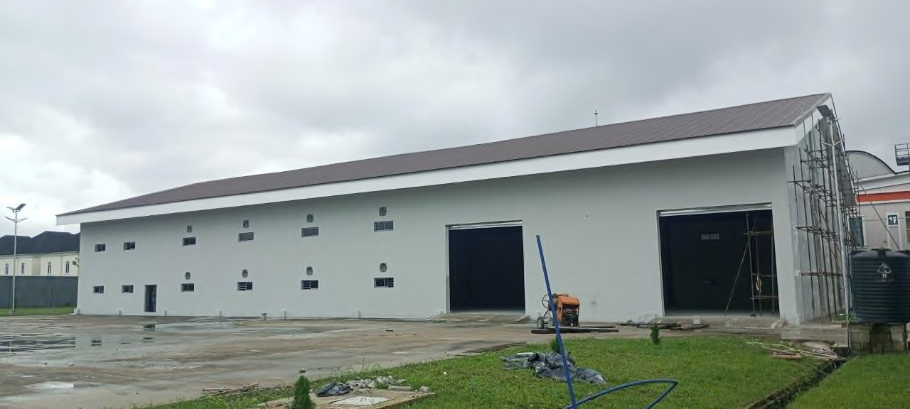 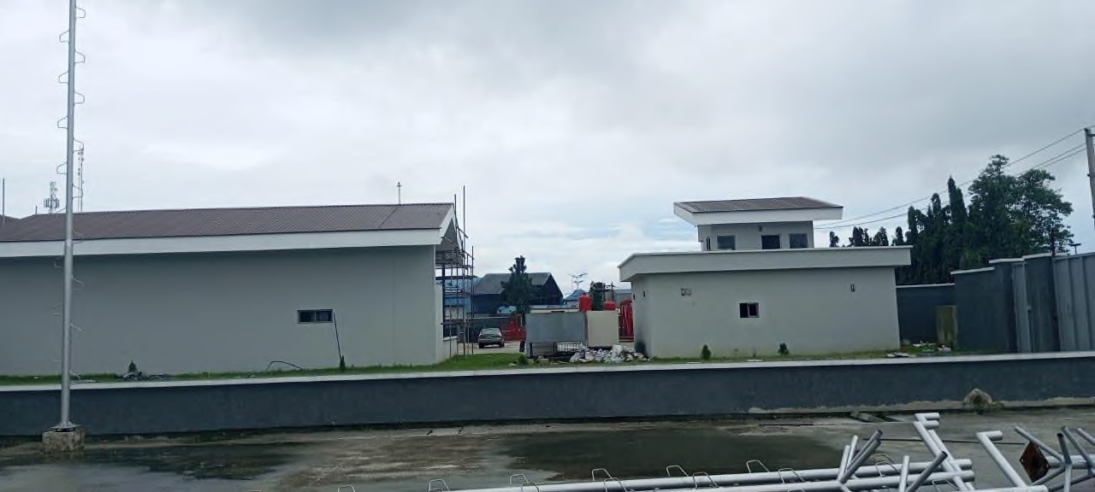

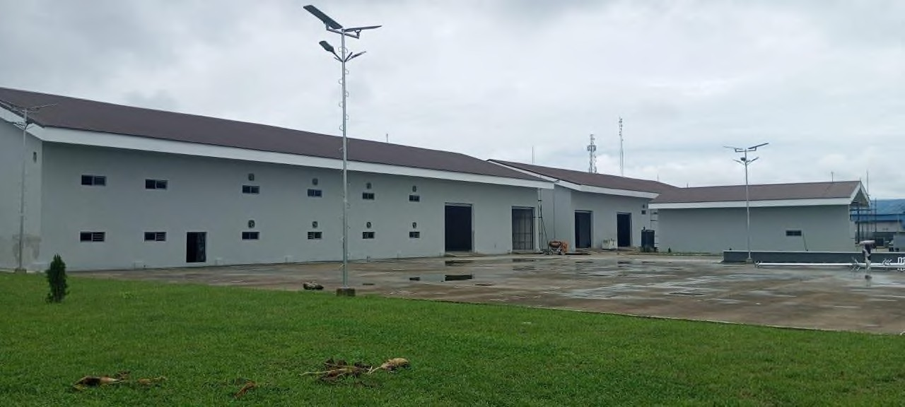

26

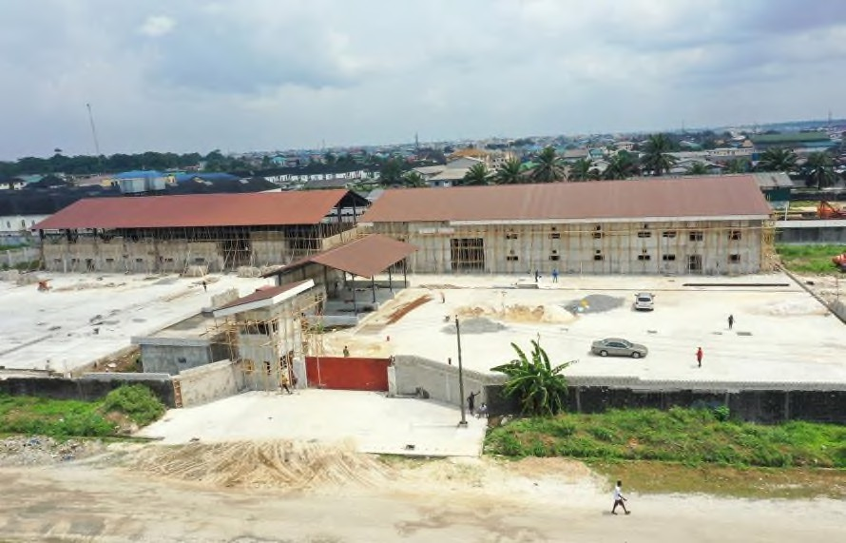 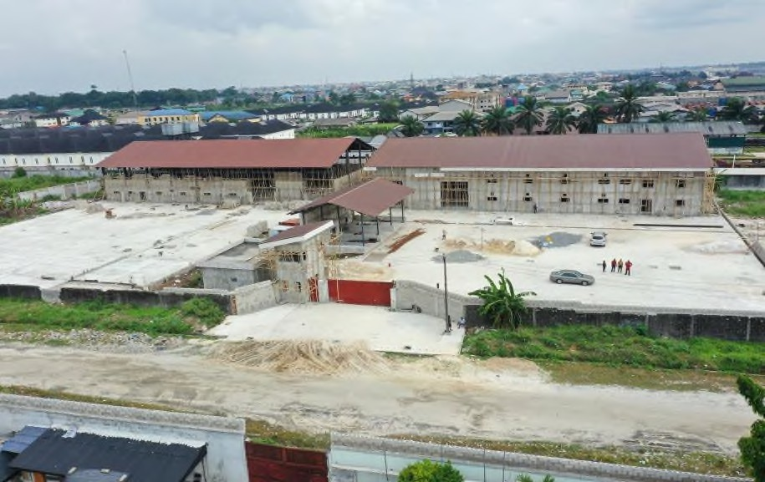

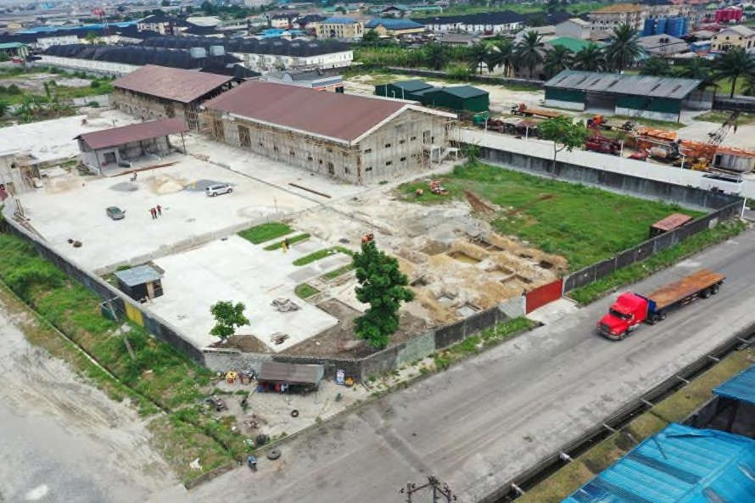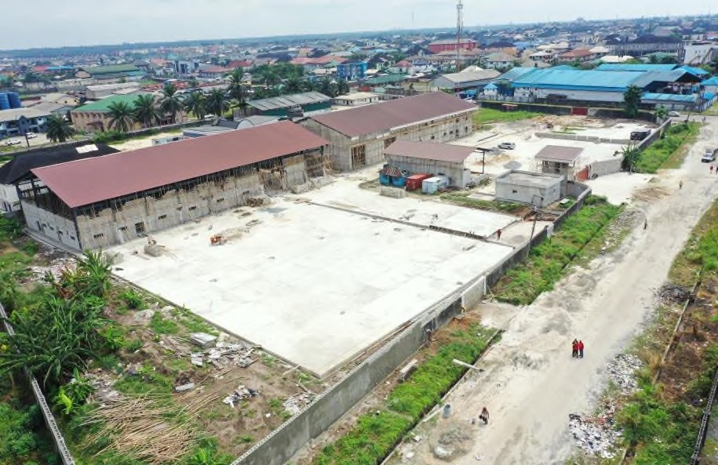

27

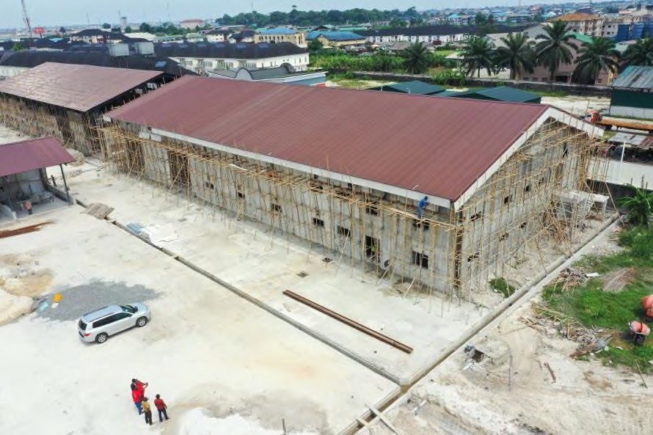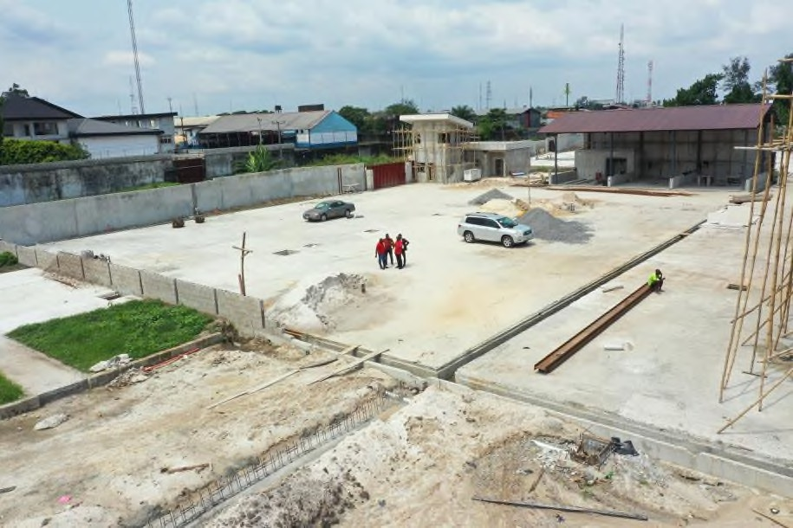

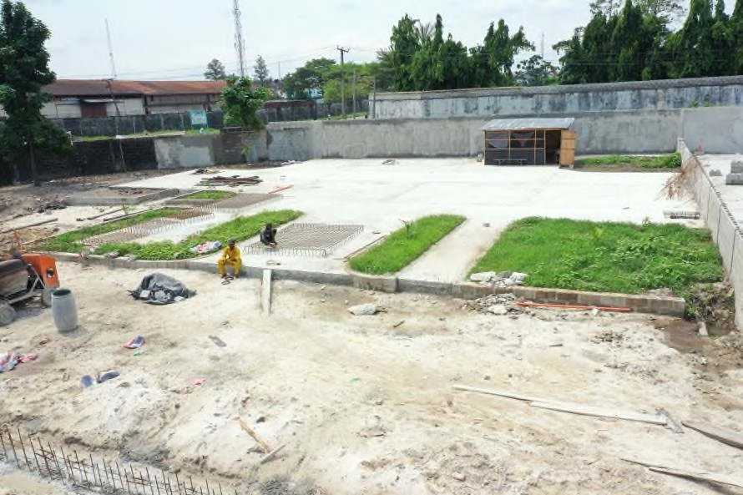

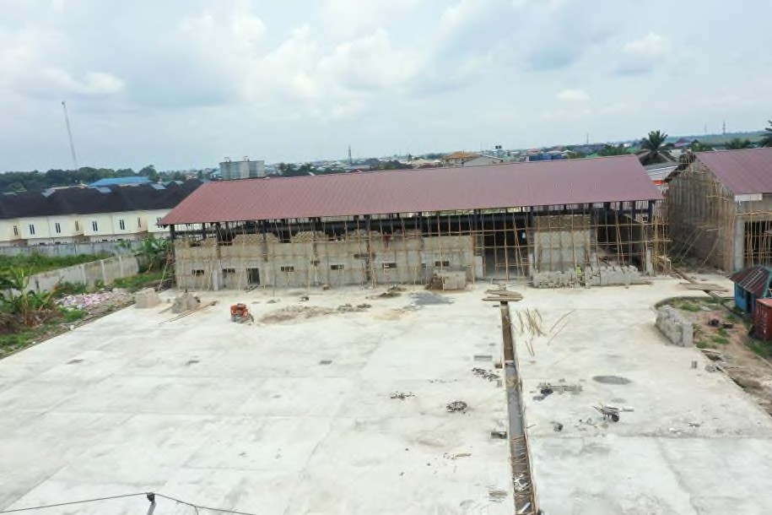

28

2

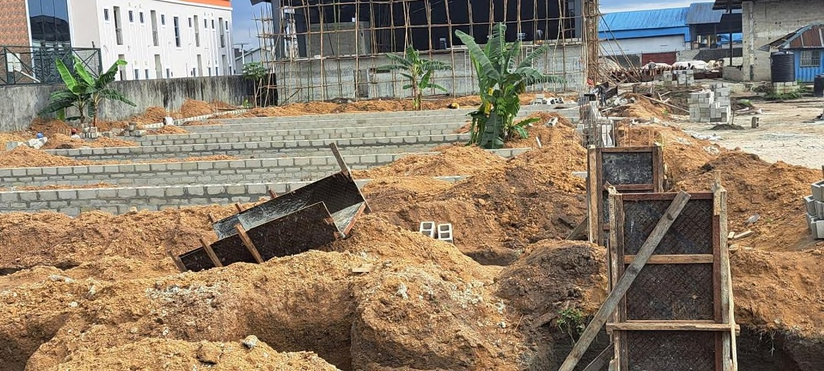 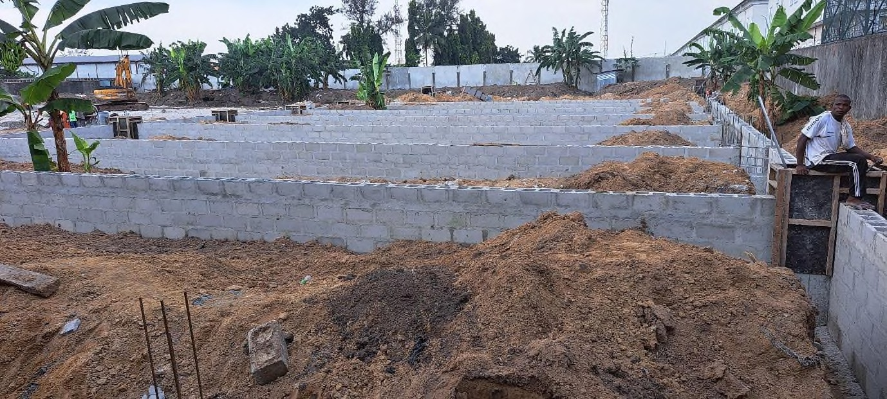

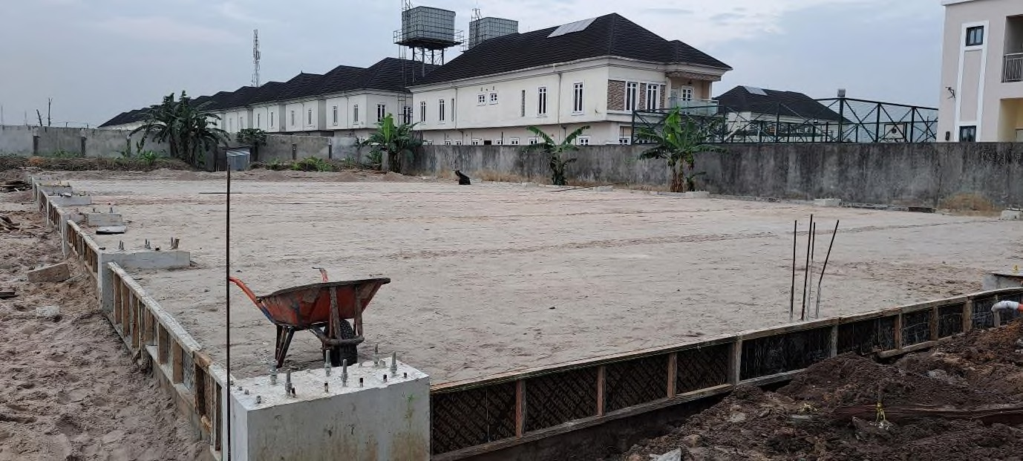

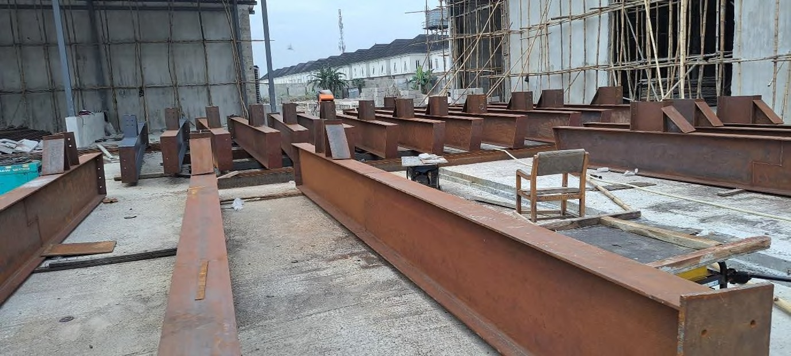

9

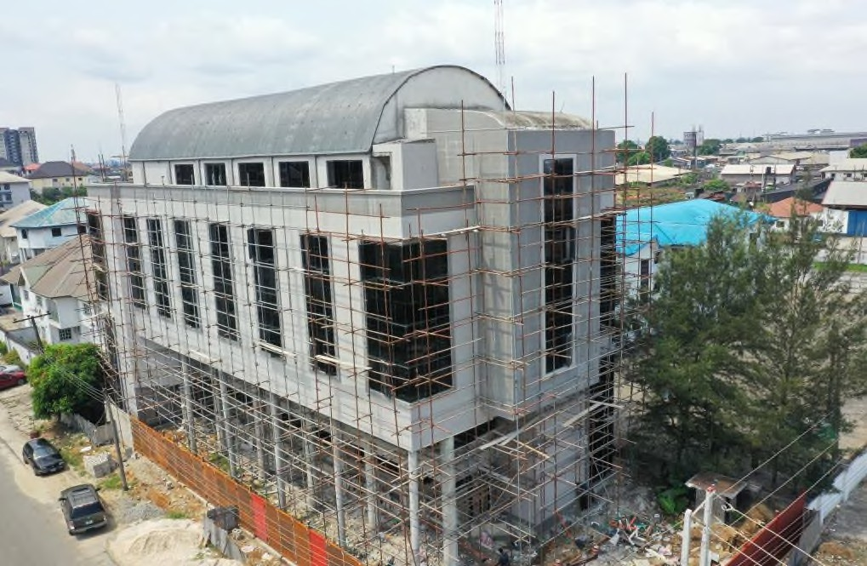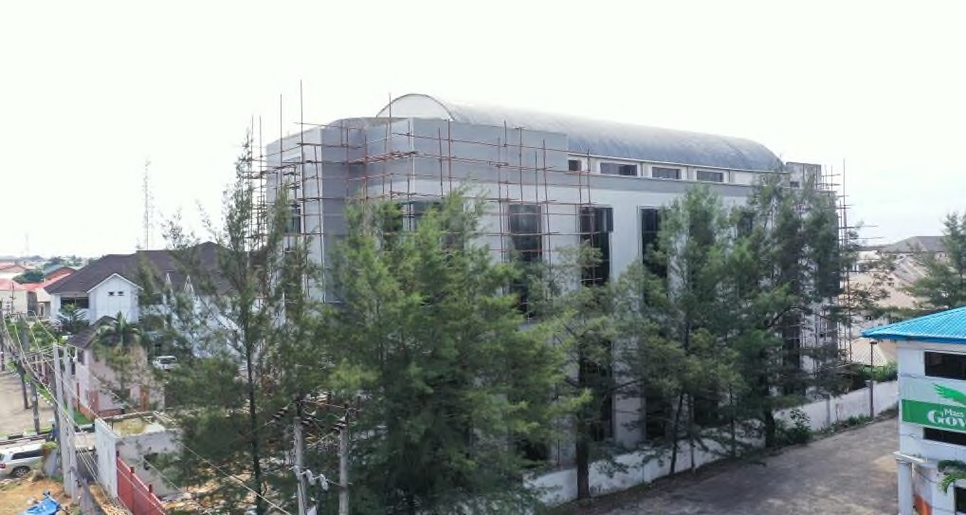

30

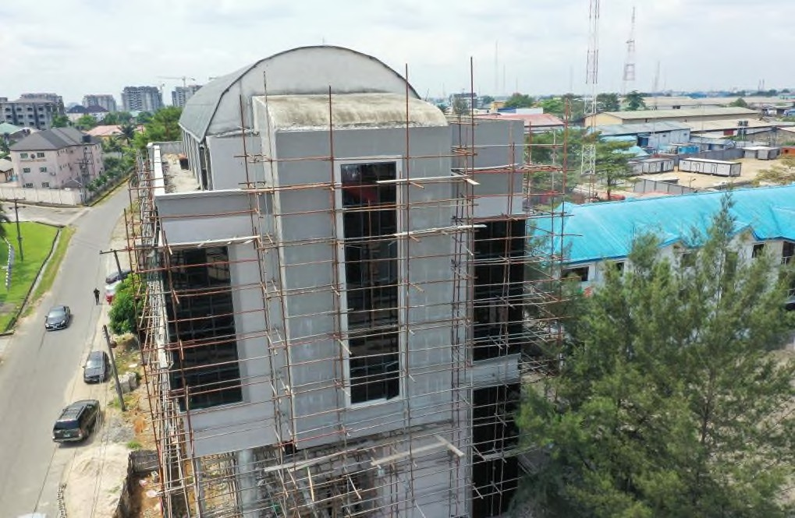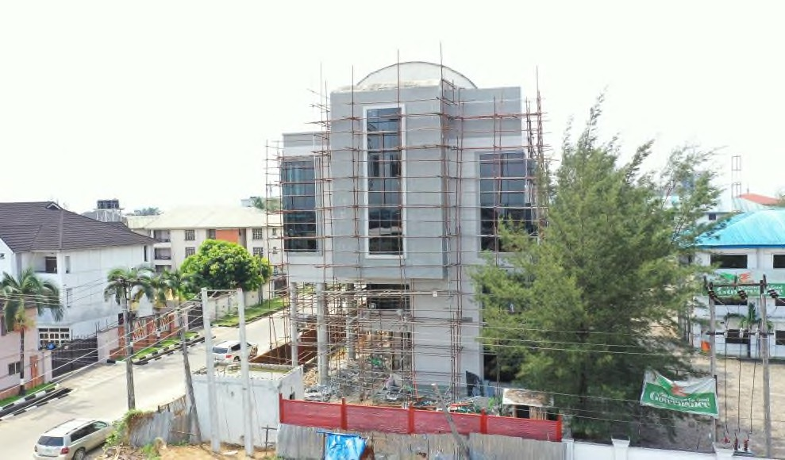

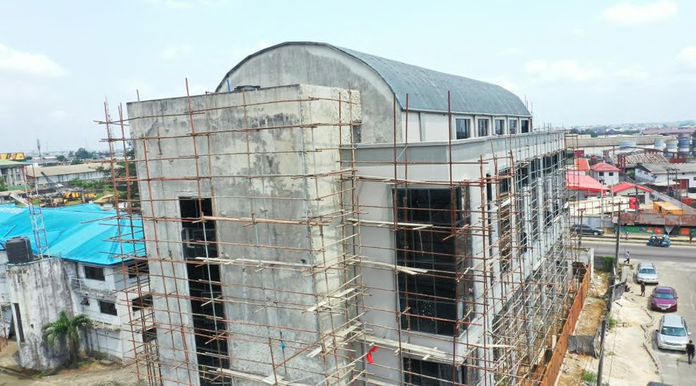

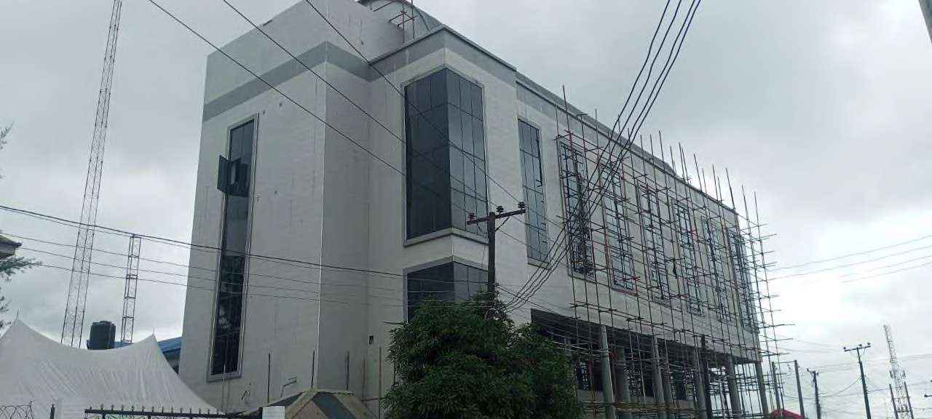 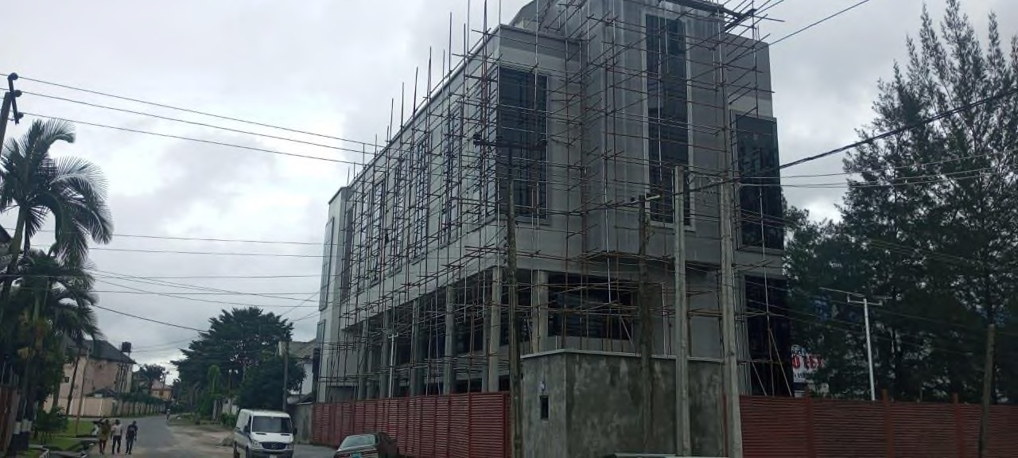

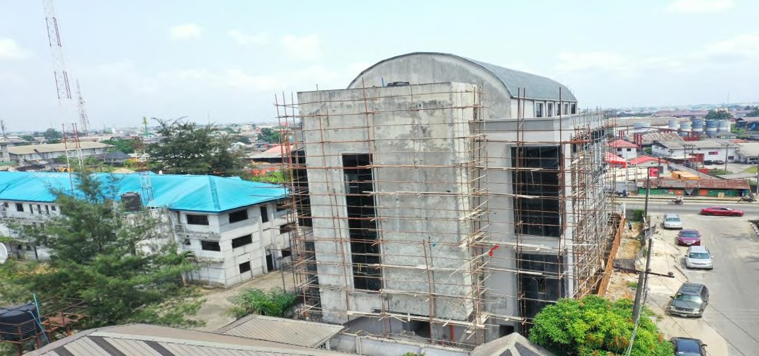

31

**PROJECT PICTURES CONT’D HOBARK INT’L OFFICE COMPLEX**

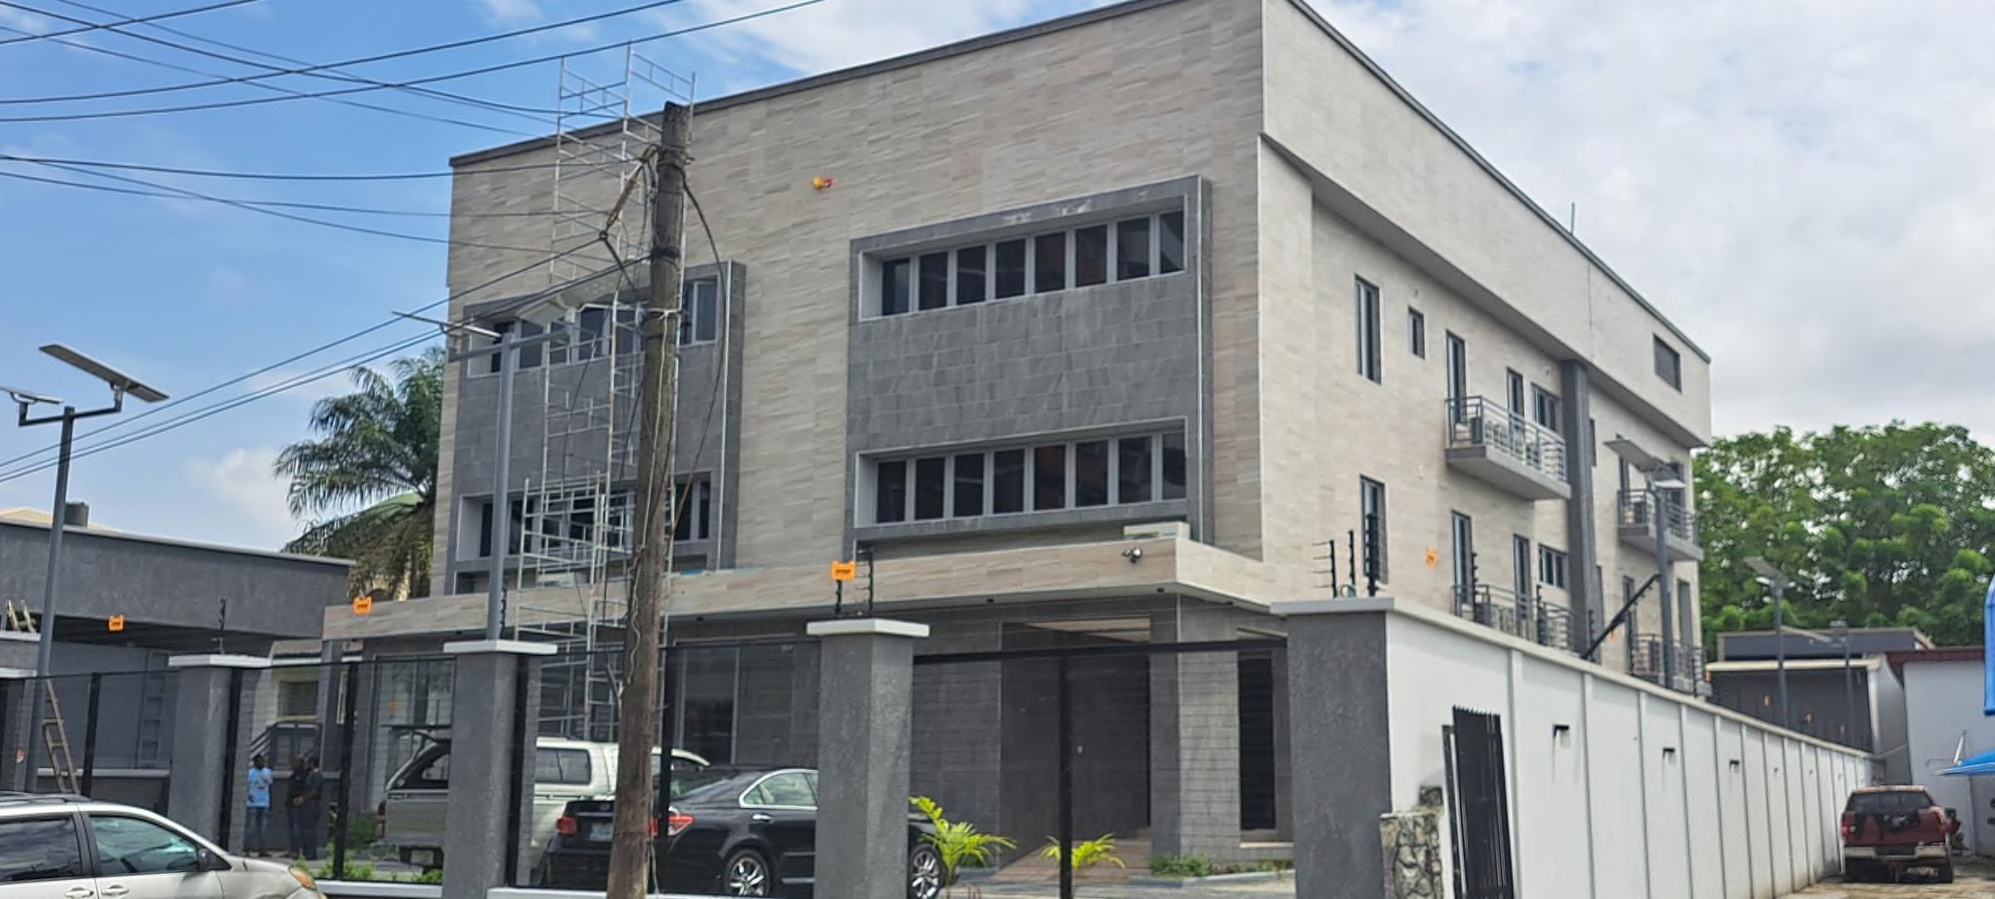

32

|  |  |  |  |
| --- | --- | --- | --- |
| **S/N** | **Some Project Title /Client** | **Amount** | **Status** |
| 1. | Construction Of Workshop/ Warehouse At Port Harcourt / Drill  Petroleum Limited | ₦400,000,000 | Completed |
|  |  |  |  |
| 2. | Construction of 54 Rooms 3 Star Hotel at GRA Port Harcourt /  Seyton Nig. Limited | ₦2,500,000,000 | Ongoing |
|  |  |  |  |
| 3. | Construction of Residential Complex at Edo State / J. I. A. Limited | ₦300,000,000 | Completed |
|  |  |  |  |
| 4. | Construction of Internal Road at Arik Air Head Office Ikeja, Lagos /  Arik Air Limited | ₦85,000,000 | Completed |

33

|  |  |  |  |
| --- | --- | --- | --- |
| **S/N** | **Some Project Title /Client** | **Amount** | **Status** |
| 5. | Rig Positioning /Mobil Producing Unlimited | ₦100,000,000 | Completed |
|  |  |  |  |
| 6. | Construction of 6No. Product and Water Tank Foundation / Foundations System Nigeria | ₦220,000,000 | Completed |
|  |  |  |  |
| 7. | Installation of 20Nos bored Piles / Foundations System Nigeria | ₦150,000,000 | Completed |
|  |  |  |  |
| 8. | Renovation of Post Graduate Hall/ Covenant University Ota | ₦100,000,000 | Completed |

34

|  |  |  |  |
| --- | --- | --- | --- |
| **S/N** | **Some Project Title /Client** | **Amount** | **Status** |
| 9. | Construction of Student Hostel/Faith Academy Ota | ₦400,000,000 | Completed |
|  |  |  |  |
| 10. | Construction of cassava Factory/DATCO- RIVERS CASSAVA Processing Company Ltd @ Afam, Rivers State | ₦294,000,000 | Completed |
|  |  |  |  |
| 11. | Construction of Rig Foundation & Mud Pump Foundation/Sterling Oil Exploration and Production Company @ Eastern Obolo, Akwa- Ibom State. | ₦89,000,000 | Completed |
|  |  |  |  |
| 12. | Design & Construction of Multi-Level Car Park Facility/Lagos State  Govt. @ Alausa Ikeja, Lagos State. | USD8.5m | Ongoing |

35

|  |  |  |  |
| --- | --- | --- | --- |
| **S/N** | **Some Project Title /Client** | **Amount** | **Status** |
| 13. | Construction of Event Centre @ 147 Woji Road GRA Port Harcourt,  Rivers State/ Harspora Nigeria Ltd | ₦695,000,000 | Completed |
|  |  |  |  |
| 14. | Construction of Classrooms/Faith Academy Port Harcourt, Rivers  State. | ₦294,000,000 | Completed |
|  |  |  |  |
| 15. | Construction of Hostel Block for Faith Academy/ Living Faith Church  Worldwide. Faith Academy Canaanland, Ota | ₦334,000,000 | Completed |
|  |  |  |  |
| 16. | Construction of Residential/Office Building @ 13A Anifowose Street, V.I, Lagos/ Hobark International Limited | ₦461,000,000 | Ongoing |
|  |  |  |  |
| 17. | Construction of Residential/Office Building @ 39 Ajanaku Street, off  Salvation Road, Awuse Estate, Opebi, Ikeja/ Sotap Enterprises Limited | ₦66,000,000 | Ongoing |

36

|  |  |  |  |
| --- | --- | --- | --- |
| **S/N** | **Some Project Title /Client** | **Amount** | **Status** |
| 18. | Construction of Industrial Complex at Plot 296Trans-Amadi Port  Harcourt, Rivers State/ CB Geophysical Solution Limited | ₦1,500,000,000 | 100% Completed |
|  |  |  |  |
| 19. | Completion of Hotel at 1 High street Trans-Amadi, Port Harcourt,  Rivers State/Vhelbherg Imperial Hotel Annex | ₦445,000,000 | 98% Completed |
|  |  |  |  |
| 20. | Construction of Workshop at Ohanze Abia State/ Palm & Crude Ltd | ₦900,000,000 | 35% Completed |
|  |  |  |  |
| 21. | Roof Work @ Ohanze Abia State/ Lobayor Global Ventures | ₦182,000,000 | 85% Completed |
|  |  |  |  |
| 22. | Construction of Workshop @ Elf road Trans- Amadi, Port Harcourt/  Uniterm Nigeria Limited | ₦125,000,000 | 60% Completed |

37

|  |  |  |  |
| --- | --- | --- | --- |
| **S/N** | **Some Project Title /Client** | **Amount** | **Status** |
| 23. | Construction of Residential Duplex at Garki Abuja/ Mr Oscar  Igbokwe | ₦550,000,000 | Construction yet to  commence |
|  |  |  |  |
| 24. | Construction of Residential Duplex at Banana Island, Lagos/ Mr  Ifeanyi Okpara | ₦500,000,000 | 5% Completed |
|  |  |  |  |
|  |  |  |  |
|  |  |  |  |
|  |  |  |  |
|  |  |  |  |
|  |  |  |  |

38

## PROJECT REFERENCE FROM CLIENTS

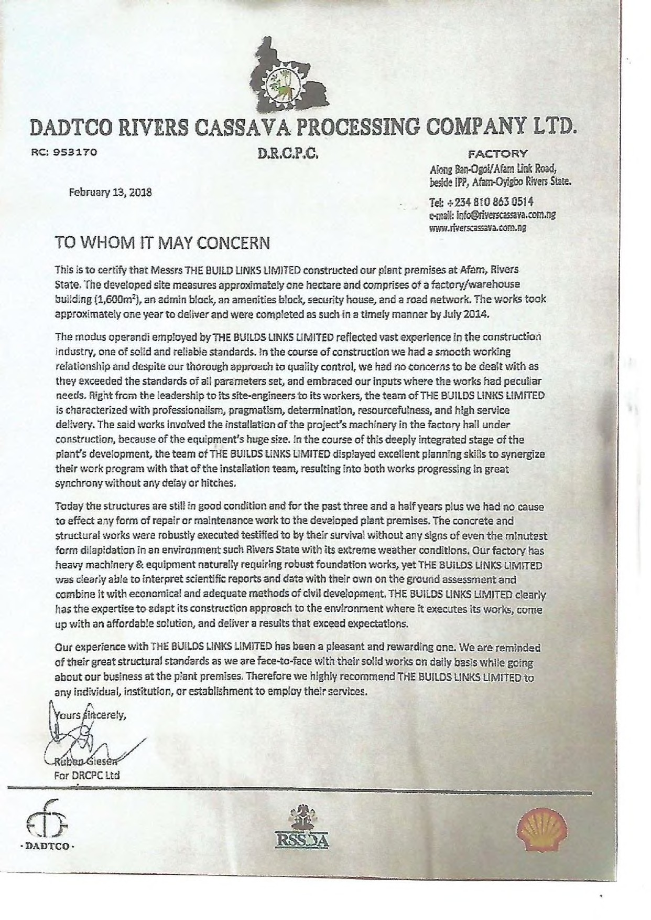39

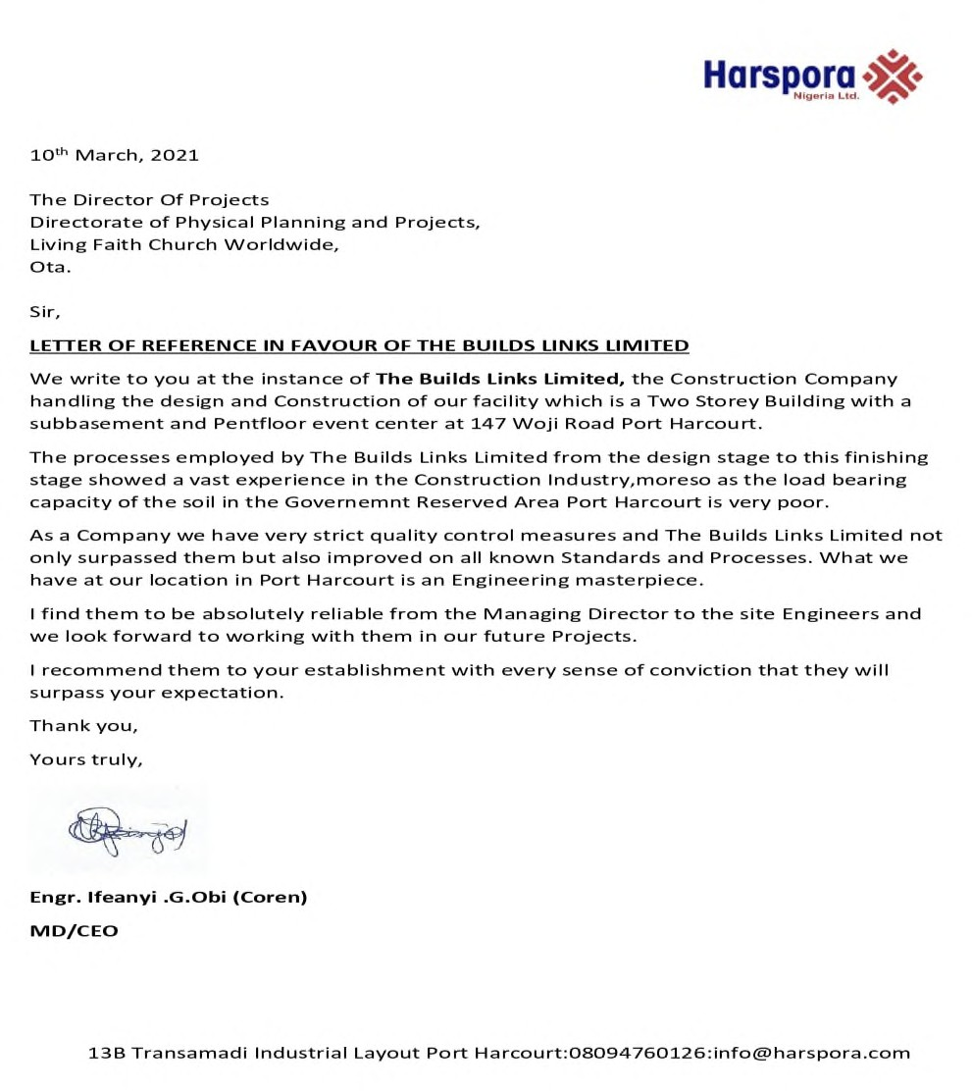

40

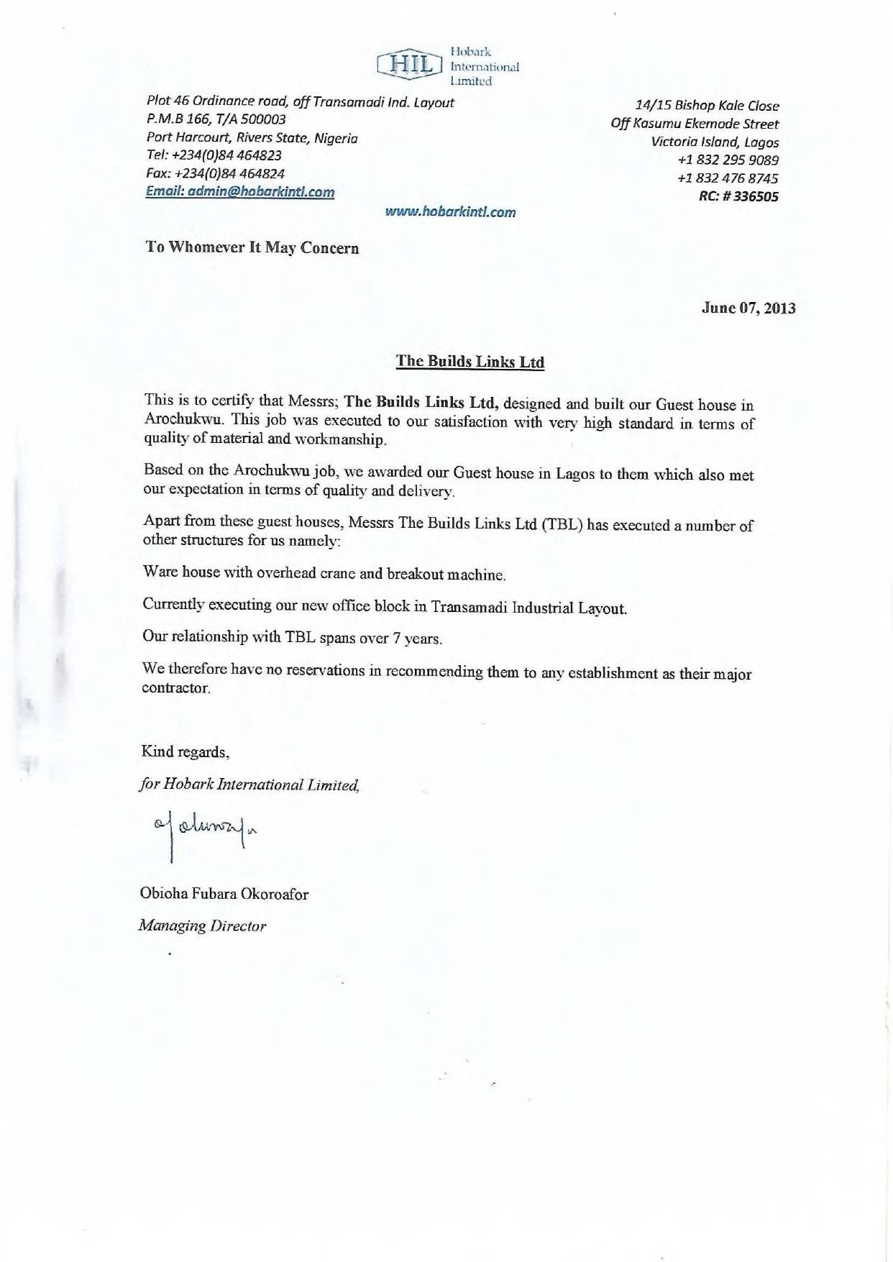

41

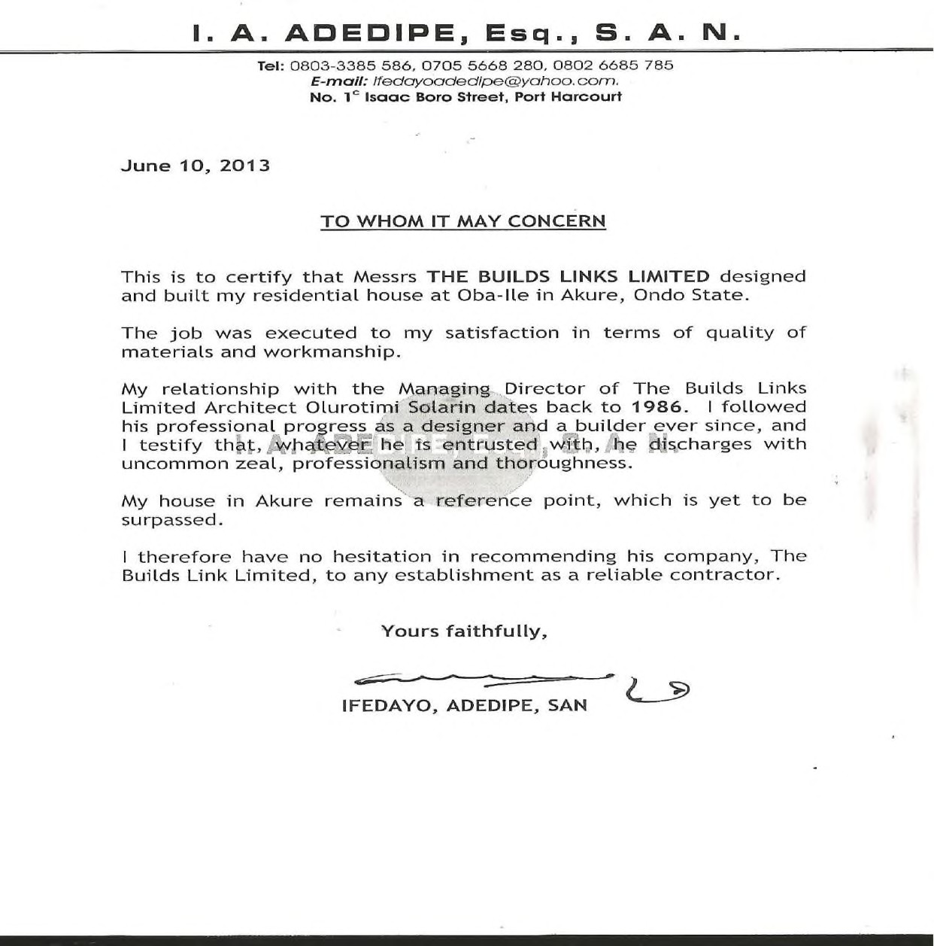

42

**THANK YOU!**

[TBL_LTD@YAHOO.COM](mailto:tbl_ltd@yahoo.com)

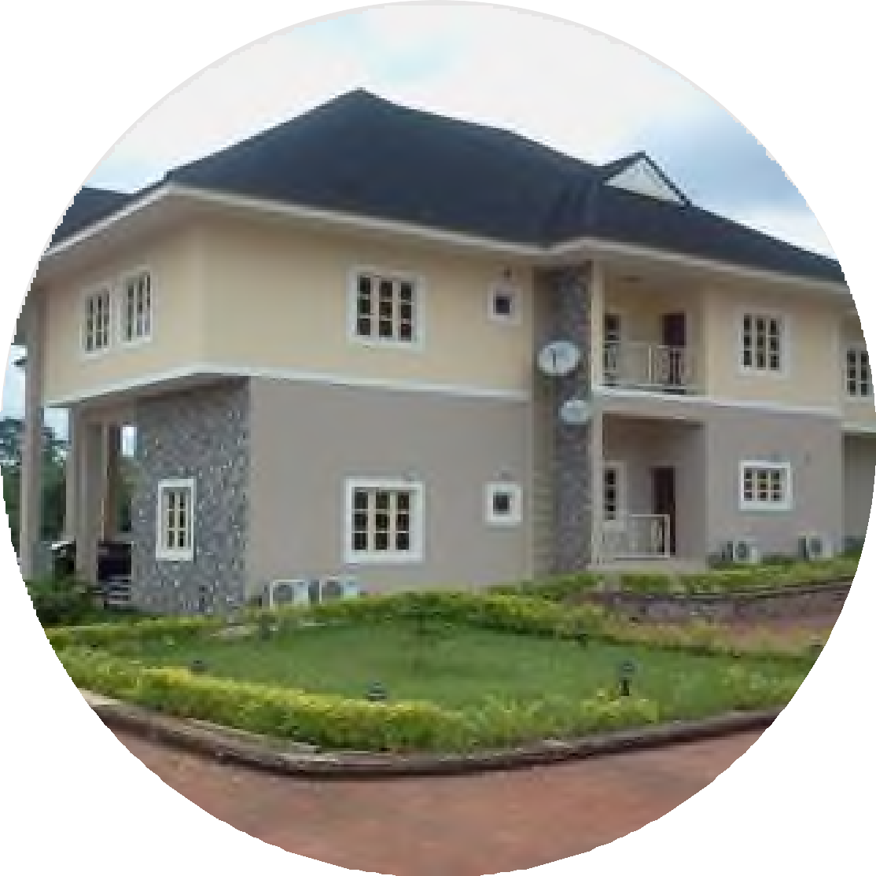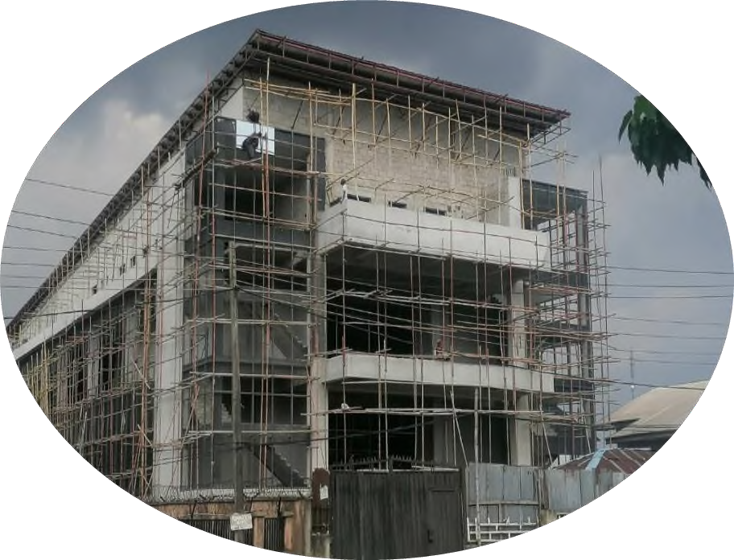

[INFO@THEBUILDLINKS.COM](mailto:INFO@THEBUILDLINKS.COM)

*PORT HARCOURT,*

*+23480 3704 2304*

*LAGOS*

*+23480 3342 0498*